Weak interactions among algae, mayflies, and tadpoles suggest communities respond weakly to mountain yellow-legged frog extinctions.

Abstract

Worldwide declines in amphibian populations and diversity have prompted investigations into the ecological roles of amphibian species and the consequences of their extinctions. In the Sierra Nevada of California, mountain yellow-legged frogs (*Rana muscosa* and *Rana sierrae*) are nearly extinct, yet their impacts on, and responses to, other species remain largely unquantified. I performed two experiments to examine mountain yellow-legged frog tadpole grazing impacts on algal communities and outcomes of competitive interactions between tadpoles and mayflies (Baetidae *Callibaetis ferrugineus* and Ameletidae *Ameletus edmundsi*). In three, 16-21 day blocks in field enclosures erected in two remote high elevation lakes, I algal abundance declined with increasing mayfly, but not tadpole,abundance.Interspecific competition with mayflies and intraspecific competition had no effects on tadpole size but, increasing tadpole abundance may have facilitated individual tadpole growth. Interspecific competition with tadpoles and intraspecific competition reduced individual mayfly size.. To test the effects of consumers on algal abundance independent of within-lake variability, I also performed a separate mesocosm experiment, in which mesocosms contained no or high densities of tadpoles and mayflies. In this experiment, tadpoles reduced algal abundance by about 50%, but did not reduce algal growth rate. Mayflies did not reduce algal abundance when alone, but reduced algal abundance in in the presence of tadpoles. In the mesocosms, the presence of interspecific competitors had no interspecific effects on either tadpoles or mayflies body size. Overall, my studies indicate that the removal of mountain yellow-legged frog tadpoles can allow benthic producers to reach higher abundance and can reduce competitors’ body sizes. The effects of tadpole and mayfly grazers were variable between the two studies. The grazing effects of tadpoles were evident only in mesocosms, while the grazing effects of mayflies and inter- and intraspecific effects on consumer body sizes were evident only in the field experiment. Nonetheless, my results indicate that mountain yellow-legged frog tadpoles can negatively impact resources and competitors, and that producers and invertebrate grazers in Sierra Nevada lake communities may experience predatory and competitive release following local extinctions of mountain yellow-legged frog tadpoles.

Keywords: *Ameletus spp.,* amphibian declines, *Callibaetis ferrugineus*, interspecific competition, *Rana muscosa, Rana sierrae,* response surface design, Sierra Nevada lakes, grazing

Introduction

Although worldwide amphibian population declines and extinctions (Stuart et al. 2004, Wake and Vredenburg 2008) have been recognized for over 25 years, the ecological consequences of most of these declines remain unquantified (but see Whiles et al. 2006, Connelly et al. 2008, Whiles et al. 2009, Colón-Gaud et al. 2009, Colón-Gaud et al. 2010a, Colón-Gaud et al. 2010b, Whiles et al. 2012, Connelly et al. 2014). Generally, extinctions or species removals can alter communities, in part through the loss of top-down resource control (Hairston et al. 1960, Paine 1966, Carpenter et al. 1985, Chalcraft and Resetarits 2003, Gruner et al. 2008) or through competitive release due to the release of resources (Holbrook and Schmitt 1995). Declines and extinctions of amphibians have the potential to change communities, but the extent to which any species shapes its community via resource consumption is likely to vary idiosyncratically (Menge 2003). The degree to which a species affects its community may depend on several factors, including the impact of the specific consumer on its resources (Shurin et al. 2002, Borer et al. 2005, Wollrab et al. 2012) and on other species that share the resources (Murdoch et al. 2003). Therefore, predictions about the ecological effects of declines or extinctions of a species should be based on quantitative measurements of its unique interactions with other community members (Simberloff 2003).

The effects of amphibian declines on freshwater and terrestrial communities will depend in part on the declining species’ impact on resources and on other consumers in its community. While over 40% of the 5700 amphibian species are declining in abundance or shrinking in distribution or both (Stuart et al. 2004), declines of anurans (–frogs and toads) are the best understood and may be the most extensive. Many have declined in abundance or have been driven extinct by habitat destruction, over-exploitation, disease, or a combination of causes (Stuart et al. 2004). Anurans, and especially their tadpoles, can play ecologically important roles (Alford 1999). Many tadpoles are benthic grazers that reduce the abundance of benthic producers (Kupferberg 1997a, 1997b, Alford 1999, Connelly et al. 2008, 2014), by up to 98% in some cases (Brönmark et al. 1991, Lamberti et al. 1992) This ability to control resources also allows tadpoles to be strong exploitative competitors, and they can induce declines in abundance, growth, and fecundity of other amphibian, insect, and invertebrate grazers (Brönmark et al. 1991, Kupferberg 1997a, 1997b). As consumers, tadpoles also can interfere with or facilitate the feeding of aquatic insects and other amphibians (Steinwascher 1978a, Kiffney and Richardson 2001 , Ranvestel et al. 2004), and can be negatively affected by interspecific competition (Morin et al. 1988) ).

Like many tadpoles, those of the endangered mountain yellow-legged frogs (*Rana muscosa* and *R. sierrae*) graze on benthic algae, and are potential competitors with mayfly nymphs, caddisfly larvae, diptera larvae, and other benthic macroinvertebrates (Grinnell and Storer 1924, Zweifel 1955, Finlay and Vredenburg 2007). Because of their historical ubiquity and abundance (Grinnell and Storer 1924), mountain yellow-legged frog tadpoles may have been ecologically importantcomponents of Sierra Nevada aquatic ecosystems ,. In lakes in the Sierra Nevada tadpoles once reached densities around 20-30 individuals per meter of lake shoreline (Roland A. Knapp, personal communication). It is now rare to find such robust populations.

Mountain yellow-legged frog and tadpole populations initially declined due to predation by stocked non-native trout (Knapp and Matthews 2000). Even after trout stocking was ended, frog populations continued to decline due to the emergence and spread of the amphibian chytrid fungus, *Batrachochytrium dendrobatidis* (Briggs et al. 2005). Currently, large mountain yellow-legged frog populations are limited to a handful of extremely high elevation lakes in Yosemite and Sequoia/Kings Canyon National Parks and the adjacent John Muir Wilderness in the southern Sierra. In most lakes in the Sierra Nevada, mountain yellow-legged frogs and their tadpoles have gone locally extinct (Briggs et al. 2010, Vredenburg et al. 2010).

To explore how declines and local extinctions of mountain yellow-legged frogs might affect Sierra Nevada lake communities, I examined the impacts of tadpoles on their resources and on potential competitors. Mountain yellow-legged frog tadpoles may reduce algal resources and compete, through exploitative or interference interactions, with co-occurring native insect grazers. I chose to study interactions between mountain yellow-legged frog tadpoles and mayfly nymphs as potential competitors with tadpoles because mayfly nymphs are abundant in Sierra Nevada lakes (Bradford et al. 1998, Epanchin et al. 2009) and can also suppress algal abundance (Bradford et al. 1998, Epanchin et al. 2009, Hill and Knight 1987, Morin et al. 1988, Dudley 1992, Hertonsson et al. 2007). I predicted that in the presence of tadpoles – as in the pristine, fish-free and disease-free state – algal abundance would be lowest; reducing tadpole abundance or presence – mimicking disease driven declines and extinctions – would increase algal abundance. In addition, I predicted that both mayflies and tadpoles would reduce algal abundance, with negative effects on their own and each others’ body sizes. To test these predictions, I performed two experiments which manipulated the presence or abundance of tadpoles to examined their effects on algal abundance and competitor body size. The results of these experiments clarify the role of mountain yellow-legged frog tadpoles in Sierra Nevada lakes, and shed light on how their extinctions might affect lake communities.

Methods

*Experimental methods*

I performed two experiments, an *in situ* field experiment and a mesocosm experiment. In the field experiment, I examined interactions between two consumers: mountain yellow-legged frog tadpoles (*Rana muscosa* and *Rana sierrae*), mayfly nymphs (Ephemeroptera: *Callibaetis ferrugineus* and *Ameletus edmundsi*), and their shared food resource (benthic organic matter: largely of diatoms but can also include green algae, cyanobacteria, chrysophytes, detritus, and bacteria; hereafter called “algae”). In the subsequent mesocosm experiment, I measured the effects of two grazers (*Rana sierrae* tadpoles and *Callibaetis ferrugineus* nymphs) on algal resources, in outdoor arenas with standard environmental conditions (nutrients, temperature, and substrates).

*Field enclosure experiment. –* In the field enclosure experiment, I used a response surface design to characterize the independent and interactive effects of grazers on their algal resources, as well as on themselves and each other (Inouye 2001). I used a full factorial design, in which four densities of tadpoles (0, 2, 10, 20) were crossed with four densities of mayflies (0, 25, 125, 250). The highest abundance treatments were set by the highest density of these consumers that colleagues and I have observed in high elevation Sierra Nevada lakes, with lower densities set at half and 1/10 of these high abundances (Roland A. Knapp, personal communication, and T. Smith diss. 2015). I performed this eaxperiment in two lakes, and in each lake at each time, each treatment was replicated once with the exception of the no-consumer control, which was replicated twice. Treatments were randomly assigned to locations within lakes. Because of the remoteness of my study lakes, it was difficult to set up additional enclosures, so experimental treatments were replicated over three different times, producing 102 data points for the study (total number of data points = 17 enclosures/lake × 2 lakes × 3 times with each time treated as a block in analysis). .

The two study lakes were remote high elevation lakes in the Kings Canyon National Park backcountry, which Irefer to as LeConte (3221 m elevation, 37°06'58.78" N 118°38'40.16" W) and Spur lakes (48 km to the southeast of LeConte, 3518 m elevation, 36°43'47.49" N 118°23'38.33" W, Google Earth 2014). . These small alpine lakes lie close to and west of the Sierra Nevada crest; while LeConte is surrounded by small meadows, white bark pine and willow patches, talus, and bare bedrock, Spur is in a basin devoid of vegetation and containing mostly talus and minimal bare bedrock. These lakes have low nutrient concentrations and circumneutral pHs: nitrate 0 – 10 μmol L-1, total phosphorus 0 – 1 μmol L-1 (Sickman et al. 2003); median pH ≅ 7 (Bradford et al. 1998). I selected these two lakes because both had large, disease-free cohorts of mountain yellow-legged frog tadpoles and large mayfly nymph populations, and are seldom visited by backpackers.

Seventeen enclosures were placed along each lake’s shoreline in the littoral zone where tadpoles feed during the day. Each enclosure was 0.5 m wide x 0.5 m tall at one end and 0.5 m wide x 1.5 m tall at the opposite end, and were 2 m long ( bottom area = 1 m2). Each was oriented perpendicular to the shoreline, so that the tall end sat in deep water, and the short end sat along the shoreline (Fig. 1), allowing tadpoles to use deep and shallow water. To accommodate emerging mayflies and tadpoles, enclosures were only partially submerged so a 25 cm tall air space remained in the top of each enclosure, and one rock from outside the lake was placed inside each enclosure to provide above-water substrate for metamorphosed frogs. , to accommodate metamorphosing tadpoles. Enclosures were supported by light weight steel frames (Sturdy Stake #ST6 www.homedepot.com) and guy-lines, and were constructed from synthetic mesh fabric, with pore size approximately 250 μm (Nitex: e.g. SKU 24-C44 www.wildco.com; polyester organza, various sources). This mesh size prevented escape of mayflies and tadpoles whilepreventing immigration by other benthic macroinvertebrates. We observed the exchange into and out of enclosures of sediment and small zooplankton (mostly Copepoda). The movement of small particles like sediment and phytoplankton through the mesh was the source from which algae were introduced into enclosures.

Tadpoles I captured and used in experiments at LeConte lake were *Rana sierrae,*  and tadpoles atSpur lake were (*Rana muscosa*); I assumed that these allopatric sister species (Vredenburg et al. 2007) are ecologically similar. After weighing and staging tadpoles (Gosner 1960), I placed those between Gosner stages 26 and 39 into enclosures (UCSB IACUC protocol #6-08-762). When individual tadpoles reached stage 39, they were released into the lake so they did not metamorphose within enclosures and each released tadpole was replaced with a younger tadpole. On average, I replaced 1.3 (SE = 0.3) tadpoles per cage per time block (about 12% ± 3 SE of the tadpoles in a cage), so many individual tadpoles were reused in the same enclosure in all three time-blocks; this was done to minimize the overall number of individuals used in the experiment and to minimize handling of experimental tadpoles. I captured mayflies in the littoral zone using benthic sweeps with a standard D-net (mesh size 250 μm), then separated mayflies without wingpads from other invertebrates in a sorting pan using flexible forceps and a turkey baster. The mayflies in LeConte lake were virtually all *Ameletus edmundsi*, but in Spur lake, *Ameletus edmundsi* and *Callibaetis ferrugineus* were present in similar proportions. Emerging adult mayflies were collected and replaced with younger individuals, with (0-40% (mean 11% ± 0.1 SE) of mayflies emerged per enclosure per block (Figure New1)..

I measured algal biomass as AFDM concentration in each enclosure as the amount of material on unglazed porcelain tiles placed on the bottom of each enclosure for the duration of each block (24 tiles, each 2.4 cm x 2.4 cm, 140 cm2 total area per enclosure). Porcelain tiles, and plastic substrates, permit algal growth sufficiently for many experimental applications (Aloi 1990). Tiles were not pre-conditioned in lakes or allowed algal growth prior to the experiment, because lakes could not be accessed until mid-July due to snow-cover. To account for potential variation in algal growth due to unquantified within-lake variation in local algae community composition, nutrient concentrations, temperature, currents, or aspect, I established a no-consumer location-within-lake control for each enclosure by placing a 12 tiles in a 6 x 12” bag made of the same 250 μm plastic mesh as enclosures with a stiff wire arch to keep it off tiles, and setting it in the littoral zone next to each enclosure (“location-within-lake” controls, Figure 1). I recorded natural substrate type below each enclosure. Soft versus hard substrates can strongly influence overlying dissolved nutrient concentrations and producer communities in lake littoral zones(Vincent and Downes 1981, Potapova and Charles 2005, T. Smith dissertation 2015), which could affect nutrient concentration in and algal immigration into the overlying enclosure. Therefore, substrate type was described as percent of the substrate below each enclosure which was composed of silt (defined as particles < 0.5mm, as in Knapp and Matthews 2000), some of which drifted into and settled in enclosures. I measured light intensity within and outside each enclosure (photosynthetic photon flux) at the water surface using a quantum meter (Apogee Instruments, Logan, UT www.apogee-inst.com). Mesh reduced light intensity by 24%, from 1977.1 ± 4.2 to 1505.0 ± 25.0 μmol photons m-2 s-1(ANOVA, F1,66=349.02, p < 0.001).

Experiments began in the early ice-free season (17 July 2009 in LeConte and 21 July 2009 in Spur), and each of three subsequent temporal blocks lasted 16-21 days. At the beginning of each block, I weighed and staged all experimental tadpoles, then placed clean tiles and targeted numbers of tadpoles and mayfly nymphs in enclosures . At the end of each block, I sampled algal, mayfly nymph, emerged adult mayfly, and tadpole abundances, and tadpole stages and weights.

I collected algal samples from tiles in enclosures and from location-within-lake control mesh bags, by scrubbing tiles using a soft-bristle toothbrush, suspending organic matter in 60 mL of water, then filtering algal suspensions onto glass fiber filters ( 1.2 μm pore size). Filters were wrapped in foil and stored in a cool dark place in the field, then transported to and frozen in the laboratory. Filters were dried at 105 °C for 24-48 hours, weighed, combusted at 500 °C for 1 hour, and then weighed again. Ash-free dry mass (AFDM) was calculated as the difference between filter-plus-sample weights before and after combustion (Hauer and Lamberti 2007). My observed algal biomasses are 1-3 orders of magnitude lower than those found in some other studies of high elevation lake periphyton (e.g. Vinebrooke and Leavitt 1996)but they are not significantly different than those I observed on artificial substrates outside of enclosures in both lakes and in one lake adjacent to LeConte (ANOVA, F2,209 = 0.09, p = 0.9).

*Mesocosm experiment. –* I also conducted a mesocosm experiment to further explore the effects of tadpoles and mayflies on algal resources, In the outdoor mesocosm experiment, I used a 2 x 2 factorial design, in which I crossed the presence and absence of tadpoles with the presence and absence of mayfly nymphs, withfour replicate mesocosms assigned to each of four treatment (no consumers, 16 tadpoles, 250 mayfly nymphs, and 16 tadpoles + 250 mayfly nynphs.

Mesocosms were located at the Sierra Nevada Aquatic Research Laboratory (SNARL) near Mammoth Lakes, CA (2165 m elevation, 37°36'50.83" N 118°49'57.56" W). and were made from sixteen cube shaped (1 m3) concrete tanks lined with Thoroseal concrete sealer, with sloping, partially submerged shelves on one side to allow tadpoles and metamorphs to bask (Fig.1). Tanks were filled with water from adjacent Convict Creek, in which nitrate and phosphate levels are similar to those observed in many Sierra Nevada lakes, but pH (is higher than in most Sierra Nevada lakes (pH 7.9 – 8.5, Leland et al. 1989, Sickman et al. 2003). Tank pHs however, were within the range observed for lakes containing high densities of mayfly nymphs and tadpoles (pH 6.5 - 8.5, Bradford et al. 1998). Mesocosms were filled in April 2010 and thirty-five sets of porcelain tiles (identical to those used in the field enclosures, total area of tiles: 2074 cm2) were placed in each mesocosm to provide standard substrates for measurement of algal abundance. Thirtytile-sets Colonizing algae came from Convict Creek water.

I collected 160 *Rana sierrae* tadpoles (Gosner stages 34-39) from Marmot Lake (John Muir Wilderness, 3590 m elevation, 37°15'36.33" N 118°41'01.38" W) and transported them to SNARL in containers with portable aerators and cooled by blocks of snow. About 3000 mayflies (*Callibaetis ferrugineus*) were collected from a small pond in Yosemite National Park (2608 m elevation, 37°53'07.18" N 119°23'39.97" W) using a D-net with 250 μm mesh size, sorted using sieves, pipettes, and turkey basters, and transported to SNARL like the to tadpoles.

The experiment began on July 26, 2010, when I added consumers to the mesocosms, and it ran for 21 days. Initially, I maintained tadpole abundance by adding younger tadpoles (Gosner stage 34 to 39) to replace metamorphosed individuals, but the experiment ended when tadpole densities could not be maintained because of high levels of tadpole metamorphosis. I was not able to maintain the mayfly treatments; mayflies were undetectable in the mesocosms, both visually and without causing substantial disturbance of benthic organic matter and experimental tiles. Thus, I was unable to measure loss of mayfly individuals, by emergence or mortality during the experiment, and to compensate for it by adding individuals. However, at the end of the experiment I exhaustively sampled each mesocosm for mayflies, sampling with a D-net until 20 consecutive sweeps of the entire mesocosm bottom collected no more mayfly nymphs. I then counted the collected mayfly nymphs.

Algal abundance on bottom tiles was determined three times during the mesocosm experiment: once prior to the start of the experiment on July 26 (n = 3 tile sets/mesocosm), and at one (n = 15/mesocosm), and three weeks (10/mesocosm). I did not sample shelf tiles. Algae was removed from each tile using a soft toothbrush and suspended in 60 mL of water, the algal suspensions were filtered through a glass fiber filter. These samples were frozen immediately, and later processed for AFDM as described above.

*Analytical methods*

For both experiments, I performed analyses to relate algal abundance to consumer abundance, and analyses to relate body size of each consumer to its abundance and to the abundance of its competitor (Table 1).

*Analysis of field enclosure experiment. –* For my analysis of field enclosure algal abundance data, , the independent variables were the continuous variables mayfly abundance and tadpole abundance, with four levels for each abundance treatment of each consumer. I included categorical covariates for experimental block, with three levels, and for lake, with two levels (LeConte and Spur). The lake covariate accounted for differences between lakes such as elevation, temperature, or size. I also included continuous covariates for duration of experimental block (days), solar radiation within enclosures, and substrates beneath enclosures.

The response variable was the difference in algal biomass(AFDM m-2) between enclosures and the adjacent within-lake-location control tiles, measured at the conclusion of each block. I used linear mixed effects models (Zuur et al. 2009) to test the response of algal abundance to variation in consumer abundance and consumer biomass. Using a step-down model fitting procedure, I selected the best-fit model based on Akaike Information Criteria (AIC) and visual inspection of model residuals (Zuur et al. 2009). The initial model included the response variable algal abundance, the predictor variables tadpole and mayfly abundance or biomass, and covariates for enclosure siltiness, light intensity, duration of experimental block, lake, and block number. I included an interaction term between consumers, because of the potential for tadpoles to either facilitate or interfere with mayfly grazing. To meet the assumption of normality of residuals, I log transformed algal biomass. I compared models that included random intercepts (for block and for lake), random slopes for consumer effects in different lakes, and allowed variance to differ among experimental blocks, lakes, and levels of mayfly and tadpole abundance (Zuur et al. 2009). To account for within-lake variability in algal abundance, I calculated a second response variable “location-within-lake controlled algal abundance”, by subtracting algal abundance in enclosures from the algal abundance on location-within-lake control tiles (e.g. AFDMlocation-within-lake control – AFDMenclosure), and I repeated the analyses.

*Analysis of mesocosm experiment. –* In my analyses of mesocosm algal abundance, the independent variables were tadpole presence-absence and final mayfly abundance (because the abundance of mayflies varied over the course of the experiment). I included an interaction term between consumers, because of the potential for tadpoles to either facilitate or interfere with mayfly grazing. I used a similar approach to fitting linear models as outlined above. I included covariates for duration of algal growth (days) and for the initial abundance of algae (log AFDM) in each mesocosm; I allowed variance to differ with respect to consumer presence-absence or abundance.

I calculated the growth rate of algae in the experiment, using the initial July algal abundance from each mesocosm as the initial abundance, the measured week 1 or 3 algal abundance as the post-treatment abundance, and the days between the beginning of the experiment and relevant sample date as the growth period. This growth rate was analyzed using generalized least squares models, similarly to the procedure described above. Analyses were performed and visualized using the nlme and ggplot2 packages in R, (The R Foundation for Statistical Computing 2012).

Results

*Field enclosure experiment. –* Tadpoles and mayflies had negative but inconsistent effects on the abundance of algae in field enclosures (Figure 2). Effects were more distinct in LeConte; the effects of both consumers were more variable in Spur (Figures 2 and 3). The best-fit model (Table 2) included a random intercept for experimental block, which allowed mean algal abundance to differ among blocks; lake, tadpole abundance, and mayfly abundance were fixed effects (Table 3). Repeating the analysis using consumer biomasses, rather than densities, produced essentially the same result, so I do not report details of those results.

When I analyzed algal abundance controlled for within-lake variability (the difference between algal abundance in enclosures and in adjacent mesh bags), only mayflies had a negative effect on algal abundance. There was a considerable effect of lake, as the variance in location-within-lake controlled algal abundance was an order of magnitude higher in Spur than in LeConte. The best fit linear mixed effects model of controlled algal abundance (Table 4) included fixed effects for mayfly abundance and for duration of block. The model also included a random intercept that allowed the controlled algal abundance to differ with respect to experimental block, nested within lake, and allowed variance of controlled algal abundance to differ among experimental blocks and between lakes (Table 5, Figure 4).

Average tadpole biomass increased with increased tadpole abundance (Figure 5) but that relationship was confounded by the interaction between tadpole abundance and lake retained in the best fit linear mixed effect model (Table 6). This model also included random intercepts and different variances for sampling blocks. Separate linear mixed effect models for each lake clarified the interaction, illustrating that tadpole abundance enhanced tadpole biomass only in LeConte (Figure 5, Table 7). The coefficient for tadpole abundance in this model suggests that, in LeConte, an increase of 4 tadpoles correlates to a 1 mg increase in average biomass of tadpoles. Mayfly abundance did not affect tadpole biomass.

In the field enclosures, higher tadpole and mayfly densities reduced body length of mayfly nymphs (Figure 6). Tadpole presence reduced mayfly length by 6-17% in *Ameletus edmundsi* in LeConte, but had no effect on either species in Spur. Higher mayfly abundance reduced mayfly length by 8-23% for *A. edmundsi* in LeConte, and 8-10% for *C. ferrugineus* in Spur. Because of the difference in mayfly species relative abundance in the two lakes, the best fit generalized least squares model included an interaction between mayfly species composition and lake; this model also allowed for different variances of mayfly length across the gradient of tadpole abundance and between the two species (Table 8). While mayflies differed in size between LeConte and Spur, this may have been due to differences in phenology; since I did not quantify instars of mayfly nymphs, I cannot address that difference as a result of competition.

*Mesocosm experiment. –* In the 2010 mesocosm experiment, tadpole presence reduced algal abundance by 50% (Figure 7). Mayfly presence did not reduce algal abundance. The best-fit model included fixed effects for tadpole presence, duration of growth, and the initial abundance of algae, and allowed variances to differ between tadpole presence-absence (Table 9). Mayfly presence-absence was not included as a fixed effect in this model. I found no difference among growth rates of algae among consumer treatments (Figure 8, ANOVA, F3,28 = 0.0011, p < 1.0).

In the mesocosms, mayfly nymph abundance declined by 50% – 100% during the experiment (Figure New 3). Live mayflies recovered from mesocosms at the conclusion of the experiment were not near metamorphosis (they did not have wing pads), nor were exuvia or emerged adults ever observed. This apparent mortality appears independent of coexistence with tadpoles; despite a trend towards larger declines in mayfly abundance in the presence of tadpoles, the difference was not significant (ANOVA, F2,6 = 0.338, p = 0.58). When I analysed mesocosm algal abundance using final mayfly abundance, rather than presence-absence, the presence of tadpoles affected the outcome: algal abundance did not increase significantly with mayfly in the absence of tadpoles, but, algal abundance declined with mayfly abundance in the presence of tadpoles (Figure 9). The best fit model of algal abundance, with respect to tadpole presence-absence and mayfly abundance, included fixed effects for a tadpole-mayfly interaction, duration of algal growth, and initial algal abundance, and allowed the variance of algal abundance to differ with tadpole presence-absence (Table 10). Mayfly presence had no effect on tadpole body length (ANOVA, F1,6 = 0.7, p = 0.4), and tadpole presence had no effect on mayfly body length (ANOVA, F1,6 = 0.5, p = 0.5).

Discussion

Overall, I found strong effects to no effects of mountain yellow-legged frog tadpoles on algal resources and mayfly competitors (see summary in Table 1). Mountain yellow-legged frog tadpoles did reduce the abundance of algae in mesocosms; however, they had no effect on algal abundance in field enclosures, suggesting that the ability of tadpoles to exert top-down control of algal abundance can be obscured by within-lake variability in algal abundance. Tadpoles appeared to compete with mayfly nymphs, as higher abundances of tadpoles reduced average size of individual mayfly nymphs in the field enclosures. On the other hand, in the mesocosms tadpoles appeared to facilitate mayfly feeding, as mayflies only reduced algal abundance when tadpoles were present. Tadpoles also seemed to facilitate their own growth, as I observed that average tadpole biomass was higher at high tadpole abundance. These endangered tadpoles have some, but not overwhelming, capacity to function as grazers, competitors and facilitators; as a result, their declines and extinctions may have only limited importance to Sierra Nevada alpine lake communities.

The mixed results of our two experiments highlight how environmental variation might weaken species interactions in communities (Chesson 2000, Menge 2003), or limit our ability to detect the consequences of those interactions. The top-down grazing pressure exerted by tadpoles or mayflies was less clear in the field enclosure experiment than in the mesocosm experiment, probably because variation in algal abundance with respect to tadpoles and mayflies was confounded by variation in bottom-up processes within study lakes. A drawback of having used a response surface design in an environment where spatial replication was not possible, such as in remote, protected study sites in Wilderness, was that I had less replication of treatments to account for these natural within-lake variations between each enclosure. For example, our enclosure in which I observed the highest algal abundances was located in a corner of Spur lake in which large amounts of pollen and other floating detritus collected and surrounded the enclosure, while enclosures a few meters to either side remained clean. This subsidy of detritus might have enriched algae in that enclosure and driven the high observed abundance; this was one of our no-consumer treatments. Within-lake heterogeneity like this had a role in obscuring the effects of consumers.

Our contradictory results in field and mesocosm experiments may represent the role that environmental variation plays in interpreting species interactions. Many experiments have concluded that tadpole grazing can reduce algal resources (e.g. Brönmark et al. 1991, Kupferberg 1997a, Alford 1999). However control of algae by aquatic grazers appears to be a general experimental result: in a meta-analysis of grazing experiments, 70% of experiments found that grazers at ambient densities reduced algal biomass (Feminella and Hawkins 1995). Grazer effects were largest in long lab experiments and were smaller for short experiments or field experiments (Feminella and Hawkins 1995), where variable conditions or environmental heterogeneity are probably more influential. Our results match that conclusion: in our field and mesocosm experiments of about the same duration, tadpoles had no effect in the field enclosures and a strong effect in the mesocosms. I are not alone in citing the effects of environmental heterogeneity as a factor obscuring the effects of grazers. In Pacific northwest streams, tailed frog tadpole exclusions did not strongly enhance algal abundance, probably because the effects of tadpole exclusion were masked by between stream variability (Lamberti et al. 1992). Algae abundance in streams in the Pacific Northwest can be controlled by either tailed frog tadpole grazing or by the availability of light, depending largely on the abiotic characteristics of an individual stream (Mallory and Richardson 2005).

Nonetheless, manipulative and natural field experiments have detected regulation of algal abundance by tadpoles, and tadpole exclusion or disease-caused extinctions released algae from top-down regulation. The exclusion of tadpoles from the benthos in Neotropical streams resulted in 111% to 200% increases in algal abundance (Ranvestel et al. 2004, Connelly et al. 2008), and after the amphibian chytrid fungus caused extinction of tadpoles in these same streams, algal abundance rapidly increased 2-6 fold (Connelly et al. 2008, 2014). This contradiction between the weak effects of mountain yellow-legged frog tadpoles and tailed frog tadpoles versus the strong effects of tropical stream tadpoles reinforces how ecological effects of amphibian declines will vary for each threatened species and with ecological context (Menge 2003). Identifying differences among these frog species and their communities may indicate when and where amphibians exert top-down control or respond to bottom-up processes.

Grazers or predators may do little to limit the abundance of their resource if intraspecific competition, long consumer generation times, or nutritional value of resources weaken correlations between consumer and resource abundances (Power 1992). Tadpoles engage in intraspecific exploitative and interference competition (Steinwascher 1978), though our observations of tadpole size do not suggest that competition in Sierra Nevada lakes is universal or strong. For tadpoles, the time between grazing and reproduction could be years – mountain yellow-legged frog individuals may spend 3 years as a tadpole and then not reproduce until years after metamorphosis. Effectiveness of tadpole grazing can also be reduced due to their ability to process the food they ingest: benthic producers like diatoms can pass through animal guts unharmed (Peterson 1987). In northern Sierra Nevada streams, foothill yellow-legged frog tadpoles do not assimilate energy from some diatoms, despite grazing on them (Furey et al. 2014), though other food supplemented with diatoms can lead to faster tadpole growth (Kupferberg et al. 1994). In the feces of our mesocosm tadpoles, diatoms appeared generally intact, many still containing chloroplasts; the feces of wild caught tadpoles is similar but also contains a high proportion of sand, which could reduce feeding efficiency and disconnect tadpole abundance from producer abundance. Furthermore, large tadpoles like those of mountain yellow legged frogs may assimilate a smaller fraction of their food than small tadpoles (Altig and McDearman 1975). Tadpole feces can also supplement their diets (Gromko et al. 1973, Steinwascher 1978a, 1978b), which would further decouple tadpole abundance from algal abundance as tadpoles’ diets include some fraction of semi-digested-then-defecatedmaterial rather than all new benthic material. These characteristics of mountain yellow-legged frog tadpoles support and may clarify why I observed weak top-down effects of tadpoles as consumers.

If tadpoles have little effect on algal resources, they do seem to interact with mayflies through competition and facilitation. Competition, especially in short experiments, may be revealed by consumer body size at different intra- or interspecific consumer, in part because changes in resource availability can affect consumer body size (de Roos and Persson 2013). In our study, I saw that despite little apparent response of the presumably shared resource to consumer abundance, mayflies were smaller at higher tadpole densities. This may be evidence of context dependent interspecific competition between tadpoles and mayflies: in LeConte, Ameletus competed with tadpoles and algal abundance was lower at higher consumer abundances, but in Spur where algal abundance was generally higher, there was no evidence of an effect of consumers on algal abundance or consumer body size. Elsewhere, other aquatic insect grazers have shown similar responses to the removal of tadpoles; mayfly and chironomid abundances increased 60% and 20% despite the removal of tailed frog tadpoles having no impact on algal abundance (Kiffney and Richardson 2001). This suggests that the loss of mountain yellow-legged frog tadpoles from Sierra Nevada lakes can lead to competitive release (Schmitt and Holbrook 1990, Holbrook and Schmitt 1995) of mayflies via freeing of algal resources, but that response is not general in all lakes. I could extrapolate the generality of the relationship between tadpoles and mayflies by combining the results of this study with those of separate large-scale invertebrate surveys performed by myself and by Roland Knapp (T. Smith diss. 2015).

While I examined the effect of tadpoles as consumers, the loss of facilitative and bottom-up roles that species play may have equal or greater impacts on communities (Bruno et al. 2003, Ellison et al. 2005, Lafferty and Kuris 2009). I found evidence that mountain yellow-legged frog tadpoles can facilitate mayflies, as mayflies in our mesocosm experiments only reduced algal abundance in the presence of tadpoles. Tadpoles can benefit their neighbors’ grazing by bioturbating silt that covers algae, leading to higher abundances of mayfly nymphs in the presence of tadpoles. This has been documented in tropical streams where tadpole bioturbation exposes algal resource which mayflies can use, and mayflies decreased when tadpoles were excluded from patches of the stream bottom (Ranvestel et al. 2004). Aggregating behavior by mountain yellow-legged frog tadpoles can create patches where dissolved nitrogen is orders of magnitude higher than in adjacent patches without tadpoles (Smith diss. 2015). Nitrogen recycling by tadpoles can enhance algal growth or diversity (Seale 1980, Vanni et al. 2002), and may be especially important in sometimes-nitrogen limited Sierra Nevada lakes (Sickman et al. 2003). This tadpole-generated subsidy to producers could cascade upwards to fuel growth by insect grazers or by tadpoles themselves. The abundance of mountain yellow-legged frog tadpoles in a lake may also cascade upwards to positively affect predators like garter snakes, (Jennings et al. 1992, Matthews et al. 2002), adult frogs, and Clark’s nutcrackers (personal observation). Clark’s nutcrackers are essential to the germination of white bark pine (Pilliod 2002), and were they to stop visiting lakes following tadpole extinctions (as rosy-finches did when mayflies declined following trout introductions,Epanchin et al. 2009) tree line forest structure could slowly change (Arno and Hoff 1989). In addition, tadpoles and adults host gut nematodes (personal observation) and internal and external microbial communities (Jani and Briggs 2014); symbionts are highly susceptible to the extinctions of their hosts (Lafferty and Kuris 2009).

The importance of the endangered mountain yellow legged frogs and tadpoles is not precluded by the equivocal effects of tadpoles on benthic producers observed in this study or the weak effects of frogs and tadpoles on macroinvertebrate communities that I have also observed (Smith diss. 2015). While our current work provides equivocal support for our prediction that extinctions of frogs and tadpoles would release communities from top-down control and exploitative competition, it does not mean that mountain yellow-legged frogs are unimportant in lakes. There are unquantified processes in which frogs and tadpoles may be important; and until these are documented, frogs and tadpoles cannot be called expendable (Simberloff 2003).

Acknowledgements

The use of tadpoles in these experiments was approved by the University of California, Santa Barbara Institutional Animal Care and Use Committee (protocol #). Sequoia-Kings Canyon and Yosemite National Parks permitted the research (), and I thank Danny Boiano for providing logistical support in the field. I thank Dan Dawson, Roland Knapp, and the staff at the Sierra Nevada Aquatic Research Laboratory for providing research and housing facilities and for logistical support. This research was supported by National Science Foundation Ecology and Evolution of Infectious Disease program (EF-0723563), by the University of California Natural Reserve System Mildred E. Mathias Grant for Graduate Student Research, the Henry Luce Foundation Environmental Science to Solutions Fellowship, and UCSB Department of Ecology, Evolution, and Marine Biology. Marina Bozinovic (UCSB EEMB Aquatic Biology ‘15) and Yishen Miao (UCSB CCS Biochemistry ‘15) contributed to the research, analysis, and text, and edited the manuscript IStephen DeLisle, Michael McFarlin, Garrison Loope, Michael Hernandez and Madelynn Johnston, Cord Dorcey, Andrea Jani, Mary Toothman, and Tate Tunstall assisted with field and/or laboratory work. Nikki Gantos, Patricia Monie, and Dominique Monie sewed the enclosures. Sally Holbrook and Scott Cooper provided valuable comments that enhanced the research and the manuscript.

Literature Cited

Alford, R. A. 1999. Ecology: resource use, competition, and predation. Tadpoles: The Biology of Anuran Larvae:240–278.

Altig, R., and W. McDearman. 1975. PERCENT ASSIMILATION AND CLEARANCE TIMES OF 5 ANURAN TADPOLES. Herpetologica 31:67–69.

Arno, S. F., and R. J. Hoff. 1989. Silvics of whitebark pine (Pinus albicaulis). United States Department of Agriculture, Forest Service General Te.

Borer, E. T., E. W. Seabloom, J. B. Shurin, K. E. Anderson, C. A. Blanchette, B. Broitman, S. D. Cooper, and B. S. Halpern. 2005. What determines the strength of a trophic cascade? Ecology 86:528–537.

Bradford, D. F., S. D. Cooper, T. M. Jenkins Jr, K. Kratz, O. Sarnelle, and A. D. Brown. 1998. Influences of natural acidity and introduced fish on faunal assemblages in California alpine lakes. Canadian Journal of Fisheries and Aquatic Sciences 55:2478–2491.

Briggs, C. J., R. A. Knapp, and V. T. Vredenburg. 2010. Enzootic and epizootic dynamics of the chytrid fungal pathogen of amphibians. Proceedings of the National Academy of Sciences 107:9695 –9700.

Briggs, C. J., V. T. Vredenburg, R. A. Knapp, and L. J. Rachowicz. 2005. Investigating the population-level effects of chytridiomycosis: An emerging infectious disease of amphibians. Ecology 86:3149–3159.

Brönmark, C., S. D. Rundle, and A. Erlandsson. 1991. Interactions between freshwater snails and tadpoles: competition and facilitation. Oecologia 87:8–18.

Bruno, J. F., J. J. Stachowicz, and M. D. Bertness. 2003. Inclusion of facilitation into ecological theory. Trends in Ecology & Evolution 18:119–125.

Carpenter, S. R., J. F. Kitchell, and J. R. Hodgson. 1985. Cascading trophic interactions and lake productivity. Bioscience 35:634–639.

Chalcraft, D. R., and W. J. Resetarits. 2003. Predator identity and ecological impacts: functional redundancy or fuctional diversity? Ecology 84:2407–2418.

Chesson, P. 2000. Mechanisms of maintenance of species diversity. Annual Review of Ecology and Systematics:343–366.

Connelly, S., C. M. Pringle, T. Barnum, M. Hunte-Brown, S. Kilham, M. R. Whiles, K. R. Lips, C. Colón-Gaud, and R. Brenes. 2014. Initial versus longer-term effects of tadpole declines on algae in a Neotropical stream. Freshwater Biology 59:1113–1122.

Connelly, S., C. M. Pringle, R. J. Bixby, R. Brenes, M. R. Whiles, K. R. Lips, S. Kilham, and A. D. Huryn. 2008. Changes in Stream Primary Producer Communities Resulting from Large-Scale Catastrophic Amphibian Declines: Can Small-Scale Experiments Predict Effects of Tadpole Loss? Ecosystems 11:1262–1276.

Dudley, T. L. 1992. Beneficial effects of herbivores on stream macroalgae via epiphyte removal. Oikos 65:121–127.

Duellman, W. E., and L. Trueb. 1994. Biology of amphibians. Johns Hopkins Univ Pr.

Ellison, A. M., M. S. Bank, B. D. Clinton, E. A. Colburn, K. Elliott, C. R. Ford, D. R. Foster, B. D. Kloeppel, J. D. Knoepp, G. M. Lovett, J. Mohan, D. A. Orwig, N. L. Rodenhouse, W. V. Sobczak, K. A. Stinson, J. K. Stone, C. M. Swan, J. Thompson, B. Von Holle, and J. R. Webster. 2005. Loss of foundation species: consequences for the structure and dynamics of forested ecosystems. Frontiers in Ecology and the Environment 3:479–486.

Epanchin, P., R. Knapp, and S. Lawler. 2009. Nonnative trout impact an alpine-nesting bird by altering aquatic insect subsidies. Ecology.

Finlay, J. C., and V. T. Vredenburg. 2007. Introduced trout sever trophic connections in watersheds: Consequences for a declining amphibian. Ecology 88:2187–2198.

Furey, P. C., S. J. Kupferberg, and A. J. Lind. 2014. The perils of unpalatable periphyton: Didymosphenia and other mucilaginous stalked diatoms as food for tadpoles. Diatom Research 29:267–280.

Google Earth. 2014. ThomasCSmith_LeConteSpur_map.kmz. https://github.com/TomCSmith/manuscript-support-files/blob/master/ThomasCSmith_LeConteSpur_map.kmz.

Gosner, K. L. 1960. A simplified table for staging anuran embryos and larvae with notes on identification. Herpetologica 16:183–190.

Grinnell, J., and T. I. Storer. 1924. Animal Life in the Yosemite: An Account of the Mammals, Birds, Reptiles, and Amphibians in a Cross-section of the Sierra Nevada. University of California Press.

Gromko, M. H., F. S. Mason, and S. J. Smith-Gill. 1973. Analysis of the crowding effect inRana pipiens tadpoles. Journal of Experimental Zoology 186:63–71.

Gruner, D. S., J. E. Smith, E. W. Seabloom, S. A. Sandin, J. T. Ngai, H. Hillebrand, W. S. Harpole, J. J. Elser, E. E. Cleland, M. E. S. Bracken, E. T. Borer, and B. M. Bolker. 2008. A cross-system synthesis of consumer and nutrient resource control on producer biomass. Ecology Letters 11:740–755.

Hairston, N. G., F. E. Smith, and L. B. Slobodkin. 1960. Community Structure, Population Control, and Competition. The American Naturalist 94:421.

Hauer, F. R., and G. A. Lamberti. 2007. Methods in stream ecology. Academic Press.

Hertonsson, P., K. Åbjörnsson, and C. Brönmark. 2007. Competition and facilitation within and between a snail and a mayfly larva and the effect on the grazing process. Aquatic Ecology 42:669–677.

Hill, W. R., and A. W. Knight. 1987. Experimental analysis of the grazing interaction between a mayfly and stream algae. Ecology 68:1955–1965.

Holbrook, S. J., and R. J. Schmitt. 1995. Compensation in resource use by foragers released from interspecific competition. Journal of Experimental Marine Biology and Ecology 185:219–233.

Inouye, B. D. 2001. Response surface experimental designs for investigating interspecific competition. Ecology 82:2696–2706.

Jani, A. J., and C. J. Briggs. 2014. The pathogen Batrachochytrium dendrobatidis disturbs the frog skin microbiome during a natural epidemic and experimental infection. Proceedings of the National Academy of Sciences:1412752111–.

Jennings, W. B., D. F. Bradford, and D. F. Johnson. 1992. Dependence of the garter snake Thamnophis elegans on amphibians in the Sierra Nevada of California. Journal of Herpetology 26:503–505.

Kiffney, P. M., and J. S. Richardson. 2001. Interactions among Nutrients, Periphyton, and Invertebrate and Vertebrate (Ascaphus truei) Grazers in Experimental Channels. Copeia 2001:422–429.

Knapp, R. A., and K. R. Matthews. 2000. Non-native fish introductions and the decline of the mountain yellow-legged frog from within protected areas. Conservation Biology 14:428–438.

Kupferberg, S. 1997a. Facilitation of periphyton production by tadpole grazing: functional differences between species. Freshwater Biology 37:427–439.

Kupferberg, S. J. 1997b. The Role of Larval Diet in Anuran Metamorphosis 1. Integrative and Comparative Biology 37:146–159.

Kupferberg, S. J., J. C. Marks, and M. E. Power. 1994. Effects of variation in natural algal and detrital diets on larval anuran(Hyla regilla) life-history traits. Copeia 1994:446–457.

Lafferty, K. D., and A. M. Kuris. 2009. Parasites reduce food web robustness because they are sensitive to secondary extinction as illustrated by an invasive estuarine snail. Philosophical Transactions of the Royal Society B: Biological Sciences 364:1659–1663.

Lamberti, G. A., S. V. Gregory, C. P. Hawkins, R. C. Wildman, L. R. Ashkenas, and D. M. DeNicola. 1992. Plant—herbivore interactions in streams near Mount St Helens. Freshwater Biology 27:237–247.

Leland, H. V., S. V. Fend, T. L. Dudley, and J. L. Carter. 1989. Effects of copper on species composition of benthic insects in a Sierra Nevada, California, stream. Freshwater Biology 21:163–179.

Mallory, M. A., and J. S. Richardson. 2005. Complex interactions of light, nutrients and consumer density in a stream periphyton–grazer (tailed frog tadpoles) system. Journal of Animal Ecology 74:1020–1028.

Matthews, K. R., R. A. Knapp, and K. L. Pope. 2002. Garter snake distributions in high-elevation aquatic ecosystems: Is there a link with declining amphibian populations and nonnative trout introductions? Journal of Herpetology 36:16–22.

Menge, B. A. 2003. The overriding importance of environmental context in determining the outcome of species-deletion experiments. Pages 16–43 *in* P. M. Kareiva and S. A. Levin, editors. The importance of species: perspectives on expendability and triage. Princeton University Press.

Morin, P. J., S. P. Lawler, and E. A. Johnson. 1988. Competition between aquatic insects and vertebrates: interaction strength and higher order interactions. Ecology 69:1401–1409.

Murdoch, W. W., C. J. Briggs, and R. M. Nisbet. 2003. Consumer-resource Dynamics. Princeton University Press.

Paine, R. T. 1966. Food web complexity and species diversity. The American Naturalist 100:65.

Peterson, C. G. 1987. Gut passage and insect grazer selectivity of lotic diatoms. Freshwater Biology 18:455–460.

Pilliod, D. S. 2002. Clark’s Nutcracker (Nucifraga columbiana) Predation on Tadpoles of the Columbia Spotted Frog (Rana luteiventris). Northwestern Naturalist 83:59–61.

Power, M. E. 1992. Top-down and bottom-up forces in food webs: do plants have primacy. Ecology:733–746.

Ranvestel, A. W., K. R. Lips, C. M. Pringle, M. R. Whiles, and R. J. Bixby. 2004. Neotropical tadpoles influence stream benthos: evidence for the ecological consequences of decline in amphibian populations. Freshwater Biology 49:274–285.

Roos, A. M. de, and L. Persson. 2013. Population and Community Ecology of Ontogenetic Development. Page 552. Princeton University Press.

Schmitt, R. J., and S. J. Holbrook. 1990. Population Responses of Surfperch Released from Competition. Ecology 71:1653–1665.

Seale, D. B. 1980. Influence of Amphibian Larvae on Primary Production, Nutrient Flux, and Competition in a Pond Ecosystem. Ecology 61:1531–1550.

Shurin, J. B., E. T. Borer, E. W. Seabloom, K. Anderson, C. A. Blanchette, B. Broitman, S. D. Cooper, and B. S. Halpern. 2002. A cross-ecosystem comparison of the strength of trophic cascades. Ecology Letters 5:785–791.

Sickman, J. O., J. M. Melack, and D. W. Clow. 2003. Evidence for nutrient enrichment of high-elevation lakes in the Sierra Nevada, California. Limnology and Oceanography 48:1885–1892.

Simberloff, D. 2003. Community and ecosystem impacts of single-species extinctions. Pages 221–234 *in* P. M. Kareiva and S. A. Levin, editors. The importance of species: perspectives on expendability and triage. Princeton University Press.

Steinwascher, K. 1978a. Interference and exploitation competition among tadpoles of Rana utricularia. Ecology 59:1039–1046.

Steinwascher, K. 1978b. The effect of coprophagy on the growth of Rana catesbeiana tadpoles. http://www.jstor.org.proxy.library.ucsb.edu:2048/stable/1443833.

Stuart, S. N., J. S. Chanson, N. A. Cox, B. E. Young, A. S. L. Rodrigues, D. L. Fischman, and R. W. Waller. 2004. Status and trends of amphibian declines and extinctions worldwide. Science 306.

The R Foundation for Statistical Computing. 2012. R: A Language and Environment for Statistical Computing. R Foundation for Statistical Computing, Vienna, Austria.

Vanni, M. J., A. S. Flecker, J. M. Hood, and J. L. Headworth. 2002. Stoichiometry of nutrient recycling by vertebrates in a tropical stream: linking species identity and ecosystem processes. Ecology Letters 5:285–293.

Vredenburg, V. T., R. Bingham, R. Knapp, J. A. T. Morgan, C. Moritz, and D. Wake. 2007. Concordant molecular and phenotypic data delineate new taxonomy and conservation priorities for the endangered mountain yellow-legged frog. Journal of Zoology 271:361–374.

Vredenburg, V. T., R. A. Knapp, T. S. Tunstall, and C. J. Briggs. 2010. Dynamics of an emerging disease drive large-scale amphibian population extinctions. Proceedings of the National Academy of Sciences 107:9689 –9694.

Wake, D. B., and V. T. Vredenburg. 2008. Are we in the midst of the sixth mass extinction? A view from the world of amphibians. Proceedings of the National Academy of Sciences 105:11466.

Wollrab, S., S. Diehl, and A. M. De Roos. 2012. Simple rules describe bottom-up and top-down control in food webs with alternative energy pathways. Ecology letters 15:935–46.

Zuur, A. F., E. N. Ieno, N. J. Walker, A. A. Saveliev, and G. M. Smith. 2009. Mixed effects models and extensions in ecology with R. Springer.

Zweifel, R. G. 1955. Ecology, distribution, and systematics of frogs of the Rana boylei group. University of California Press.

Tables

|  |  |  |
| --- | --- | --- |
| Response | Result | Location |
| (F) Algal abundance vs. grazer abundance | Tadpole abundance marginally reduced algal abundance; mayfly abundance had no significant effect | Table 2,3; Fig. 2, 3 |
| (F) Algal abundance vs. grazer biomass | Tadpole biomass marginally reduced algal abundance; mayfly biomass had no effect |  |
| (F) Algal abundance controlled for within-lake variation | Mayfly abundance reduced algal abundance; duration of experiment had a positive effect. Tadpole abundance has no effect. | Table 4, 5; Fig. 4 |
| (M) Algal abundance vs. grazer presence | Tadpoles reduced algal abundance about 50%; mayfly presence had no effect | Table 9, Fig. 7 |
| (M) Algal abundance vs. tadpole presence-absence and mayfly abundance | Mayflies reduced algal abundance, but only when tadpoles were present | Table 10, Fig. 9 |
| (M) Algal growth rate vs. grazer presence | Algal growth rates did not differ among grazer treatments | Fig. 8 |
| (F) Mayfly length, with respect to grazer abundance | Both tadpole and mayfly abundance reduced mayfly body length. | Table 8, Fig. 6 |
| (M) Mayfly length, with respect to tadpole presence abundance | Tadpole presence reduced mayfly length | Table 11, Fig. 10 (not included yet 11/24) |
| (F) Tadpole biomass, with respect to grazer abundance | Tadpole abundance increased tadpole biomass, but only in one lake. Mayflies had no effect. | Table 6, 7, Fig. 5 |
| (M) Tadpole biomass, with respect to mayfly presence | No effect of mayfly presence on tadpole biomass |  |

Table 1. Summary of response variables analyzed, results, and location in manuscript. The relevant experiment is indicated with the letter (F) field enclosure experiment in lakes in Kings Canyon National Park or (M) mesocosm experiment at Sierra Nevada Aquatic Research Laboratory.

|  |  |  |  |  |
| --- | --- | --- | --- | --- |
| Fixed effects | Response variable transformation | Random effects | Heterogeneity of variances | ∆ AIC |
| Tadpole Abundance x Mayfly Abundance + Lake +  Days in Block + Silt + Radiation + Block |  |  |  | 127.2 |
| Tadpole Abundance x Mayfly Abundance + Lake +  Days in Block + Silt + Radiation + Block | Log transformed |  |  | 2.9 |
| Tadpole Abundance x Mayfly Abundance + Lake +  Days in Block + Silt + Radiation | Log transformed | Block |  | 4.6Increases normality of residuals |
| Tadpole Abundance x Mayfly Abundance +  Days in Block + Silt + Radiation + Block | Log transformed | Lake |  | 9.1 |
| Tadpole Abundance x Mayfly Abundance +  Days in Block + Silt + Radiation | Log transformed | Block nested in Lake |  | 10.2 |
| Tadpole Abundance x Mayfly Abundance + Lake +  Days in Block + Silt + Radiation | Log transformed | Block | By lake | -24.5  decreases normality of residuals |
| Tadpole Abundance x Mayfly Abundance + Lake +  Days in Block + Silt + Radiation | Log transformed | Block | By block | 2.6decreasesnormality of residuals |
| Tadpole Abundance + Mayfly Abundance + Lake +  Silt + Radiation | Log transformed | Block |  | 1.9 |
| **Tadpole Abundance + Mayfly Abundance + Lake** | **Log transformed** | **Block** |  | **0** |

Table 2. Summary of models of raw algal abundance in 2009 field enclosure experiment, using numerical tadpole and mayfly abundance as the independent variables. We used a model selection procedure based on graphical interpretation of residuals and Akaike information criteria; the best-fit model is indicated by bold-face. ∆ AIC compares the model to the best-fit model.

|  |  |  |  |  |
| --- | --- | --- | --- | --- |
|  | Linear model coefficient | t96 | p-value | Random intercept |
| Tadpole Abundance | -0.03 ± 0.01 | -1.8 | 0.08 |  |
| Mayfly Abundance | -0.002 ± 0.001 | -1.3 | 0.19 |  |
| Lake | AFDMSpur 1.1 ± 0.23 > AFDMLeConte | 4.6 | <0.0001 |  |
| Block |  |  |  | Random intercept ~ N(0, 0.022) |

Table 3. Terms of best-fit model of log transformed raw algal abundance in 2009 field enclosure experiment, using numerical tadpole and mayfly abundance as independent variables.

|  |  |  |  |
| --- | --- | --- | --- |
| Fixed effects | Random effects | Heterogeneity of variances | AIC |
| Tadpole Abundance x Mayfly Abundance + Lake + Siltiness + Radiation+No. of Days |  |  | 136.90 |
| Tadpole Abundance x Mayfly Abundance + Lake + Siltiness + Radiation + No. of Days | Block |  | 140.6; but reduces correlation fitted- residuals correlation and increases normality of residuals |
| Tadpole Abundance x Mayfly Abundance + Lake + Siltiness + Radiation | Random slope for No. of Days nested within random intercept for Block |  | 145.2 |
| Tadpole Abundance x Mayfly Abundance + Lake + Siltiness + Radiation + No. of Days | Block | Lake, Block | 5.9 |
| Mayfly Abundance + No. of Days | Block | Lake, Block | 0 |

Table 4. Models of controlled algal abundance for 2009 field enclosure experiment, using numerical tadpole and mayfly abundance as the independent variables. ∆ AIC compares the model to the best-fit model.

|  |  |  |  |  |  |
| --- | --- | --- | --- | --- | --- |
|  | Linear model coefficient | t96 | p-value | Random intercept | Combined Variance structure |
| Mayfly Abundance | -0.0011 | -3.7 | 0.0004 |  |  |
| Duration of Block | -0.07 | -1.2 | 0.22 |  |  |
| Lake |  |  |  |  | σLeConte = 0.332  σSpur = 3.362 |
| Block |  |  |  | Random intercept ~ N(0, 0.482) | σblock 1 ~ N(0, 0.482)  σblock 2 ~ N(0, 0.272)  σblock 3 ~ N(0, 0.222) |

Table 5. Description of best-fit model of location-within-lake controlled algal abundance.

|  |  |  |  |  |  |
| --- | --- | --- | --- | --- | --- |
| Term | Coefficient | t89 | P | Intercept | Variance |
| Tadpole Abundance | 0.29 ± 0.09 | 3.3 | 0.001 |  |  |
| Lake | 0.92 ± 1.6 | 0.57 | 0.57 |  |  |
| Tadpole Abundance x Lake | -0.40 ± 0.012 | -3.3 | 0.002 |  |  |
| Experimental Block |  |  |  | ~N(0, 3.82) | σJuly ~N(0, 3.12)  σEarly August ~N(0, 6.82)  σLate August ~N(0, 5.02)  σSeptember ~N(0, 5.02) |

Table 6. Summary of best fit model of tadpole biomass; initial model included tadpole abundance, mayfly abundance, lake, and sampling block.

|  |  |  |  |  |  |  |
| --- | --- | --- | --- | --- | --- | --- |
| Lake | Term | Coefficient | t43 | p | Intercept | Variance |
| LeConte | Tadpole Abundance | 0.26 ± 0.08 | 3.1 | 0.003 |  |  |
|  | Experimental Block |  |  |  | ~N(0, 2.92) | σJuly ~N(0, 3.62)  σEarly August ~N(0, 5.42)  σLate August ~N(0, 4.42)  σSeptember ~N(0, 4.12) |
| Spur | Tadpole Abundance | -0.11 ± 0.08 | -1.3 | 0.19 |  |  |
|  | Experimental Block |  |  |  | ~N(0, 4.32) | σJuly ~N(0, 2.52)  σEarly August ~N(0, 8.12)  σLate August ~N(0, 5.52)  σSeptember ~N(0, 5.52) |

Table 7. Summary of best fit model of tadpole biomass in each of the two study lakes, to illustrate the interaction between lake and tadpole abundance.

|  |  |  |  |  |
| --- | --- | --- | --- | --- |
|  | Coefficient | t(5, 29) | p-value | Variance |
| Tadpole abundance | -0.01 ± 0.006 | -2.3 | 0.03 | σtadpole = 0 = 1.132  σtadpole = 2 = 0.902  σtadpole = 10 = 1.322  σtadpole = 20 = 0.222 |
| Mayfly abundance | -0.004 ± 0.0006 | -6.6 | <0.0001 |  |
| Mayfly species | -2.9 ± 0.13 | -21.3 | <0.0001 | σ*Callibaetis* = 0.062  σ*Ameletus* = 0.222 |
| Lake | -3.1 ± 0.19 | -16.7 | <0.0001 |  |
| Mayfly species x Lake | 2.9 ± 0.20 | 14.3 | <0.0001 |  |

Table 8. For 2009 field enclosures, summary of best fit model of mayfly length.

|  |  |  |  |  |
| --- | --- | --- | --- | --- |
|  | Linear model coefficient | t32 | p-value | Variance |
| Tadpole | -0.04 ± 0.01 | -2.7 | < 0.01 | σno tadpoles = 0.452  σtadpoles present = 0.772 |
| Duration of algal growth | -0.05 ± 0.02 | 3.4 | 0.002 |  |
| Log(initial algae abundance) | 0.59 ± 0.28 | 2.1 | 0.05 |  |

Table 9. For 2010 mesocosm experiment, ANOVA table for best fit linear mixed-effects model of log(algal abundance), relative to tadpole and mayfly presence-absence, duration of algal growth, and initial log(algal abundance).

|  |  |  |  |  |
| --- | --- | --- | --- | --- |
|  | Linear model coefficient | t26 | p-value | Variance |
| Tadpole Presence | -0.02 ± 0.02 | -1.2 | 0.25 | σno tadpoles = 0.442  σtadpoles present = 0.732 |
| Final Mayfly Abundance | 0.003 ± 0.002 | 1.4 | 0.18 |  |
| Tadpole Presence x Final Mayfly Abundance | 0.05 ± 0.014 | 3.6 | 0.002 |  |
| Duration of algal growth | 0.71 ± 0.28 | 2.5 | 0.02 |  |
| Log(Initial algal abundance) | -0.0008 ± 0.0004 | -2.2 | 0.04 |  |

Table 10. For 2010 mesocosm experiment, best fit linear mixed-effects model of log transformed algal abundance, as a function of tadpole presence-absence, final mayfly abundance, the interaction between consumers, duration of algal growth, and of initial algal abundance.Figures

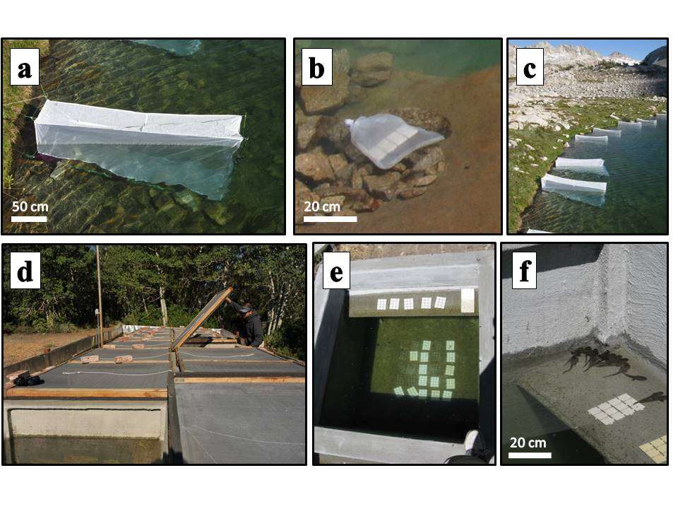

FIG. 1. a) *in situ* experimental mesh enclosure in LeConte lake, b) no consumer location-within-lake control tiles in bag of same mesh as enclosure and placed next to enclosure, c) Field enclosures in LeConte lake in Kings Canyon National Park, d) mesocosms located at Sierra Nevada Aquatic Research Laboratory in Mammoth Lakes, CA, e) view of experimental tiles and algal growth in one mesocosm, and f) tadpoles basking on shelf in a mesocosm.

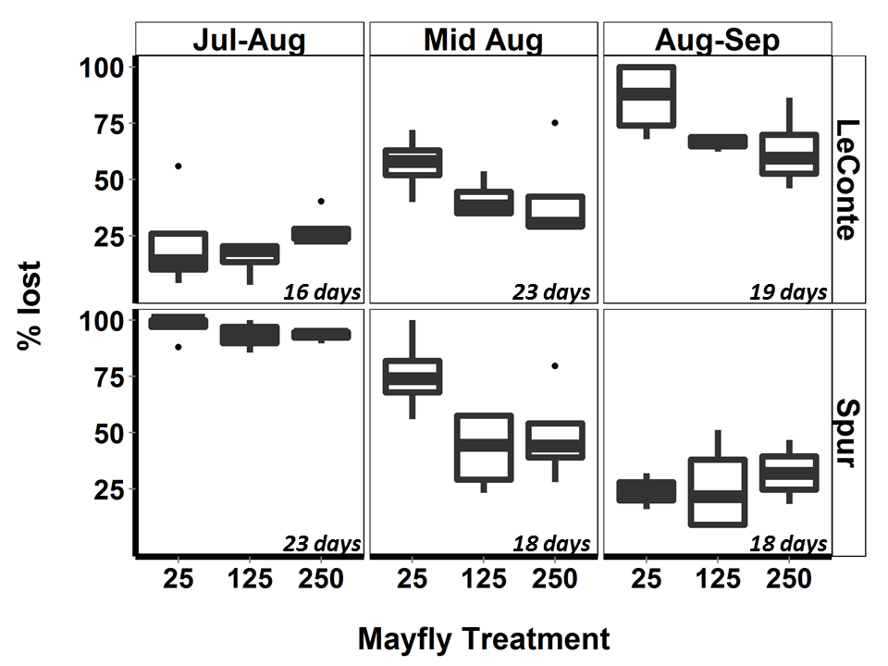

FIG. New 1: Proportional change in mayfly abundance in field experiment enclosures, with respect to mayfly density treatments (nymphs per enclosure), experimental time-blocks, lakes; these mayflies were subsequently replaced with new individuals. Emergence rates differed between all time-blocks within each lake, and differed between lakes in time-blocks 1 and 3 (ANOVA, F5,65 = 30.4, p < 0.001, Tukey’s HSD, all p < 0.02); emergence did not differ for mayfly treatments within any lake-time-block.

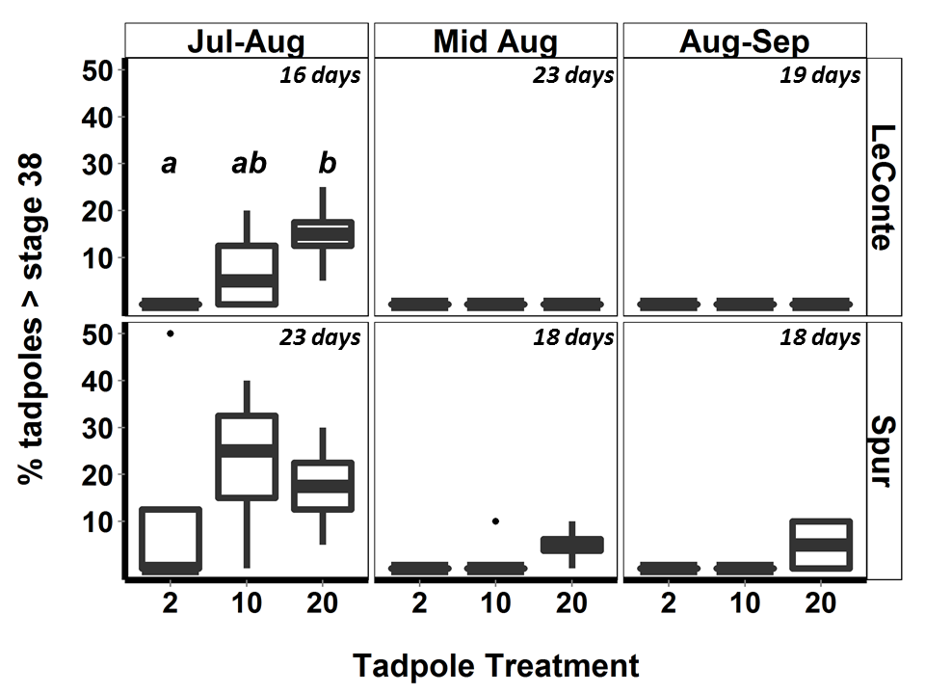

FIG New 2. Percent of tadpoles at Gosner stage > 38 with respect to tadpole density treatments (tadpoles per enclosure), experimental time-blocks and to lake; these tadpoles were subsequently removed from enclosures and replaced by younger individuals. Tadpole development differed between lakes and between time-blocks (highest in the late July-early August block, p < 0.001 , not different between mid-August and late August-September blocks (ANOVA, F5,65 = 16, Tukey’s HSD, p = 0.02 for lake difference, and p < 0.001 for within lake differences between late July-early August and other time-blocks). Letters indicate within lake-time-block differences among tadpole treatments (Tukey’s HSD, p < 0.05).

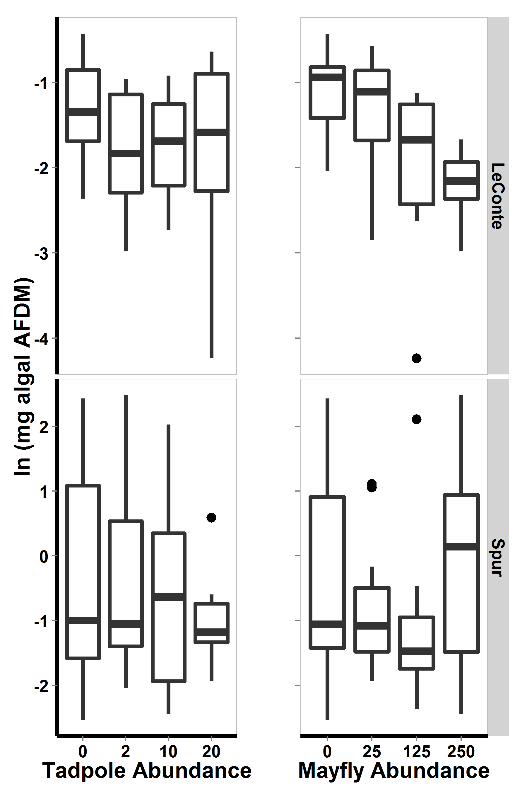

Figure 2. For 2009 field enclosure experiment, algal abundance with respect to lake and to each consumer. In all boxplots, heavy bars show medians, boxes include 50% of the data, and whiskers include 95% of the data.

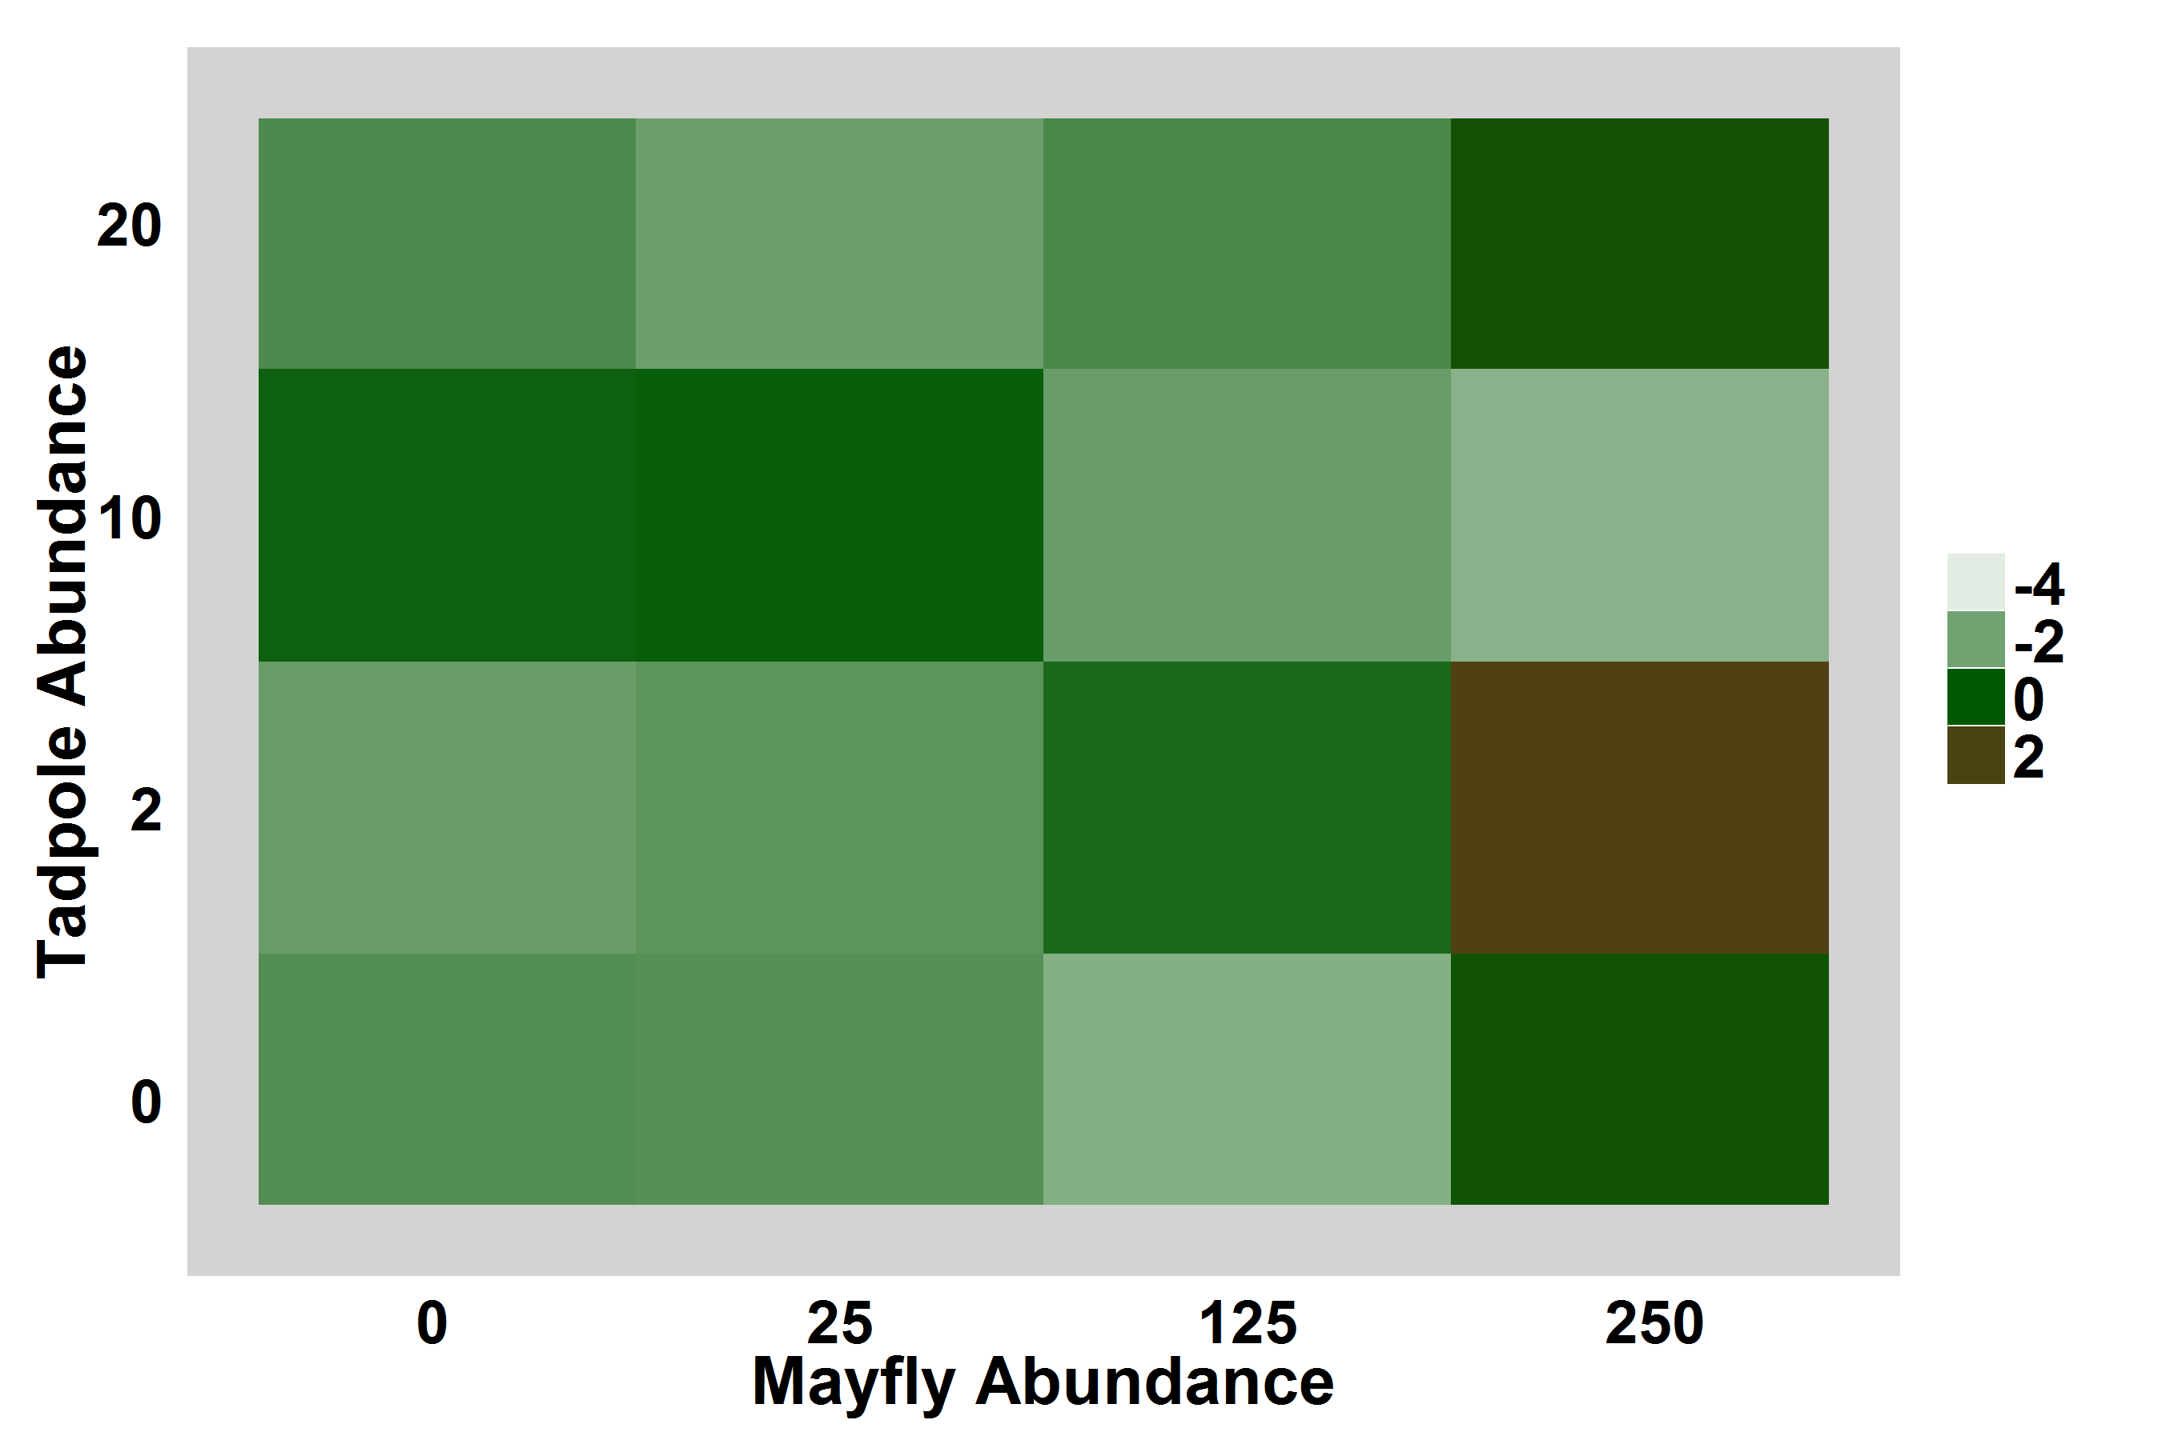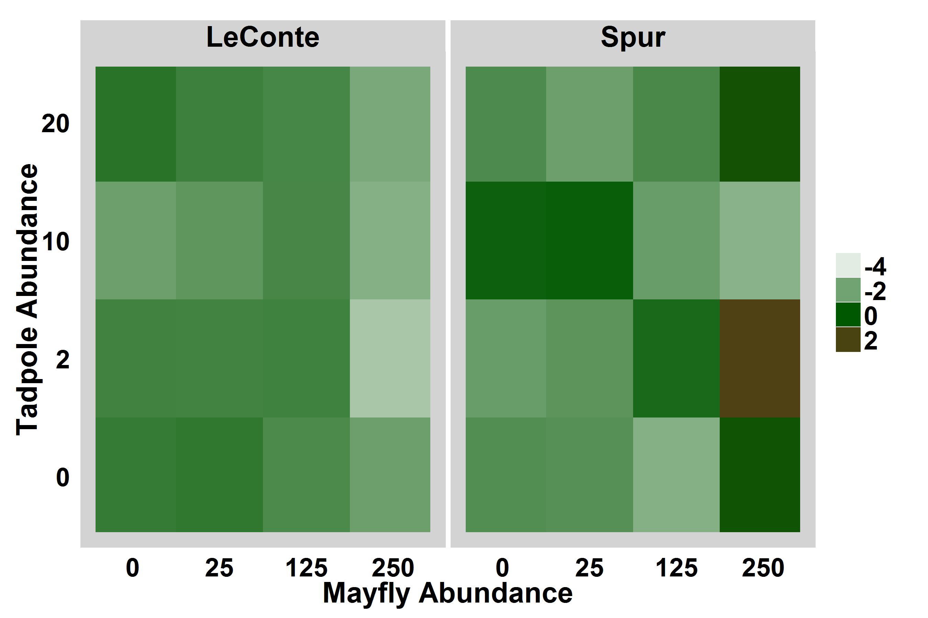

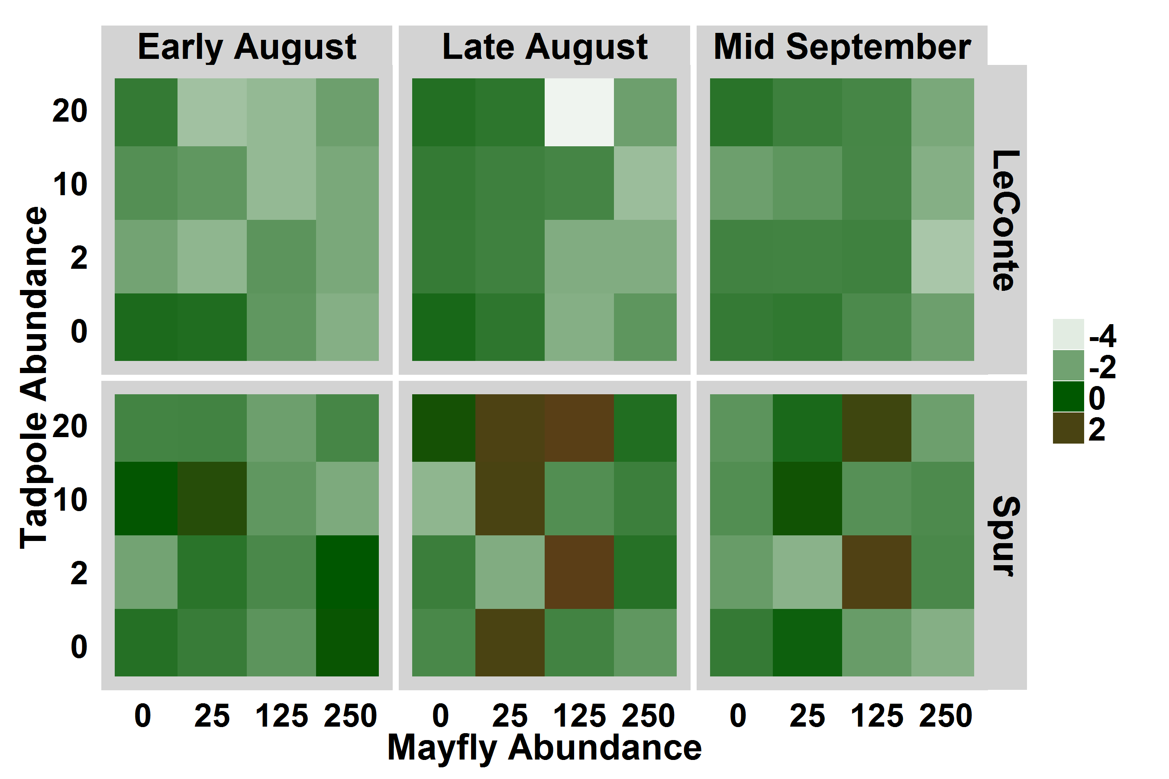

Figure 3. For 2009 field enclosure experiment, heat map displaying log-transformed algal abundance with respect to consumer densities and lake, averaged over experimental blocks. Brown indicates high algal abundance.

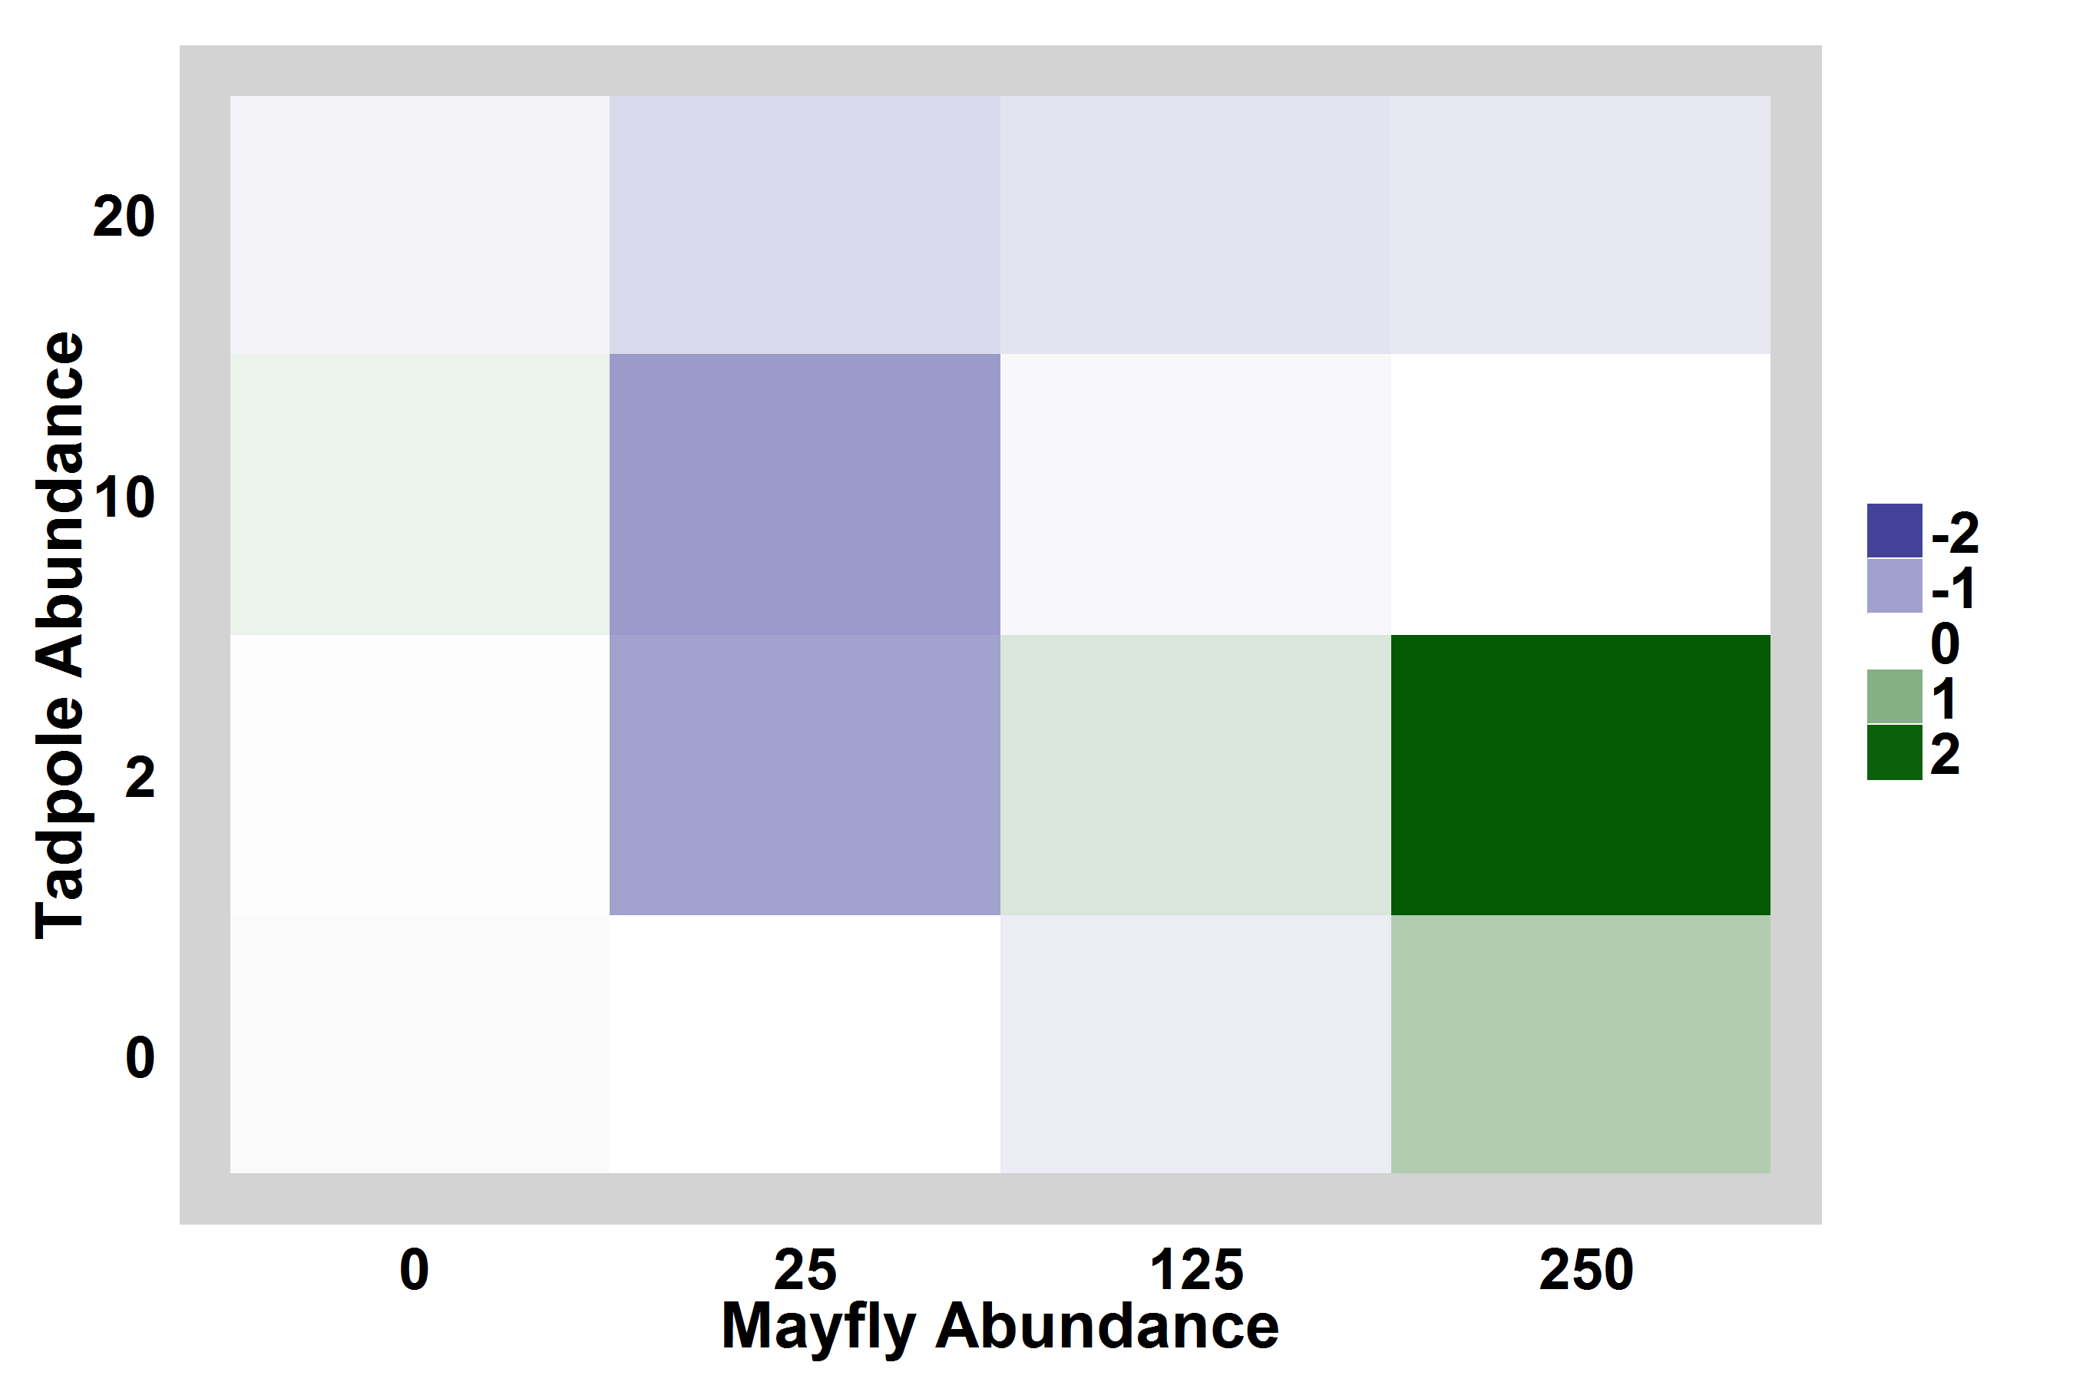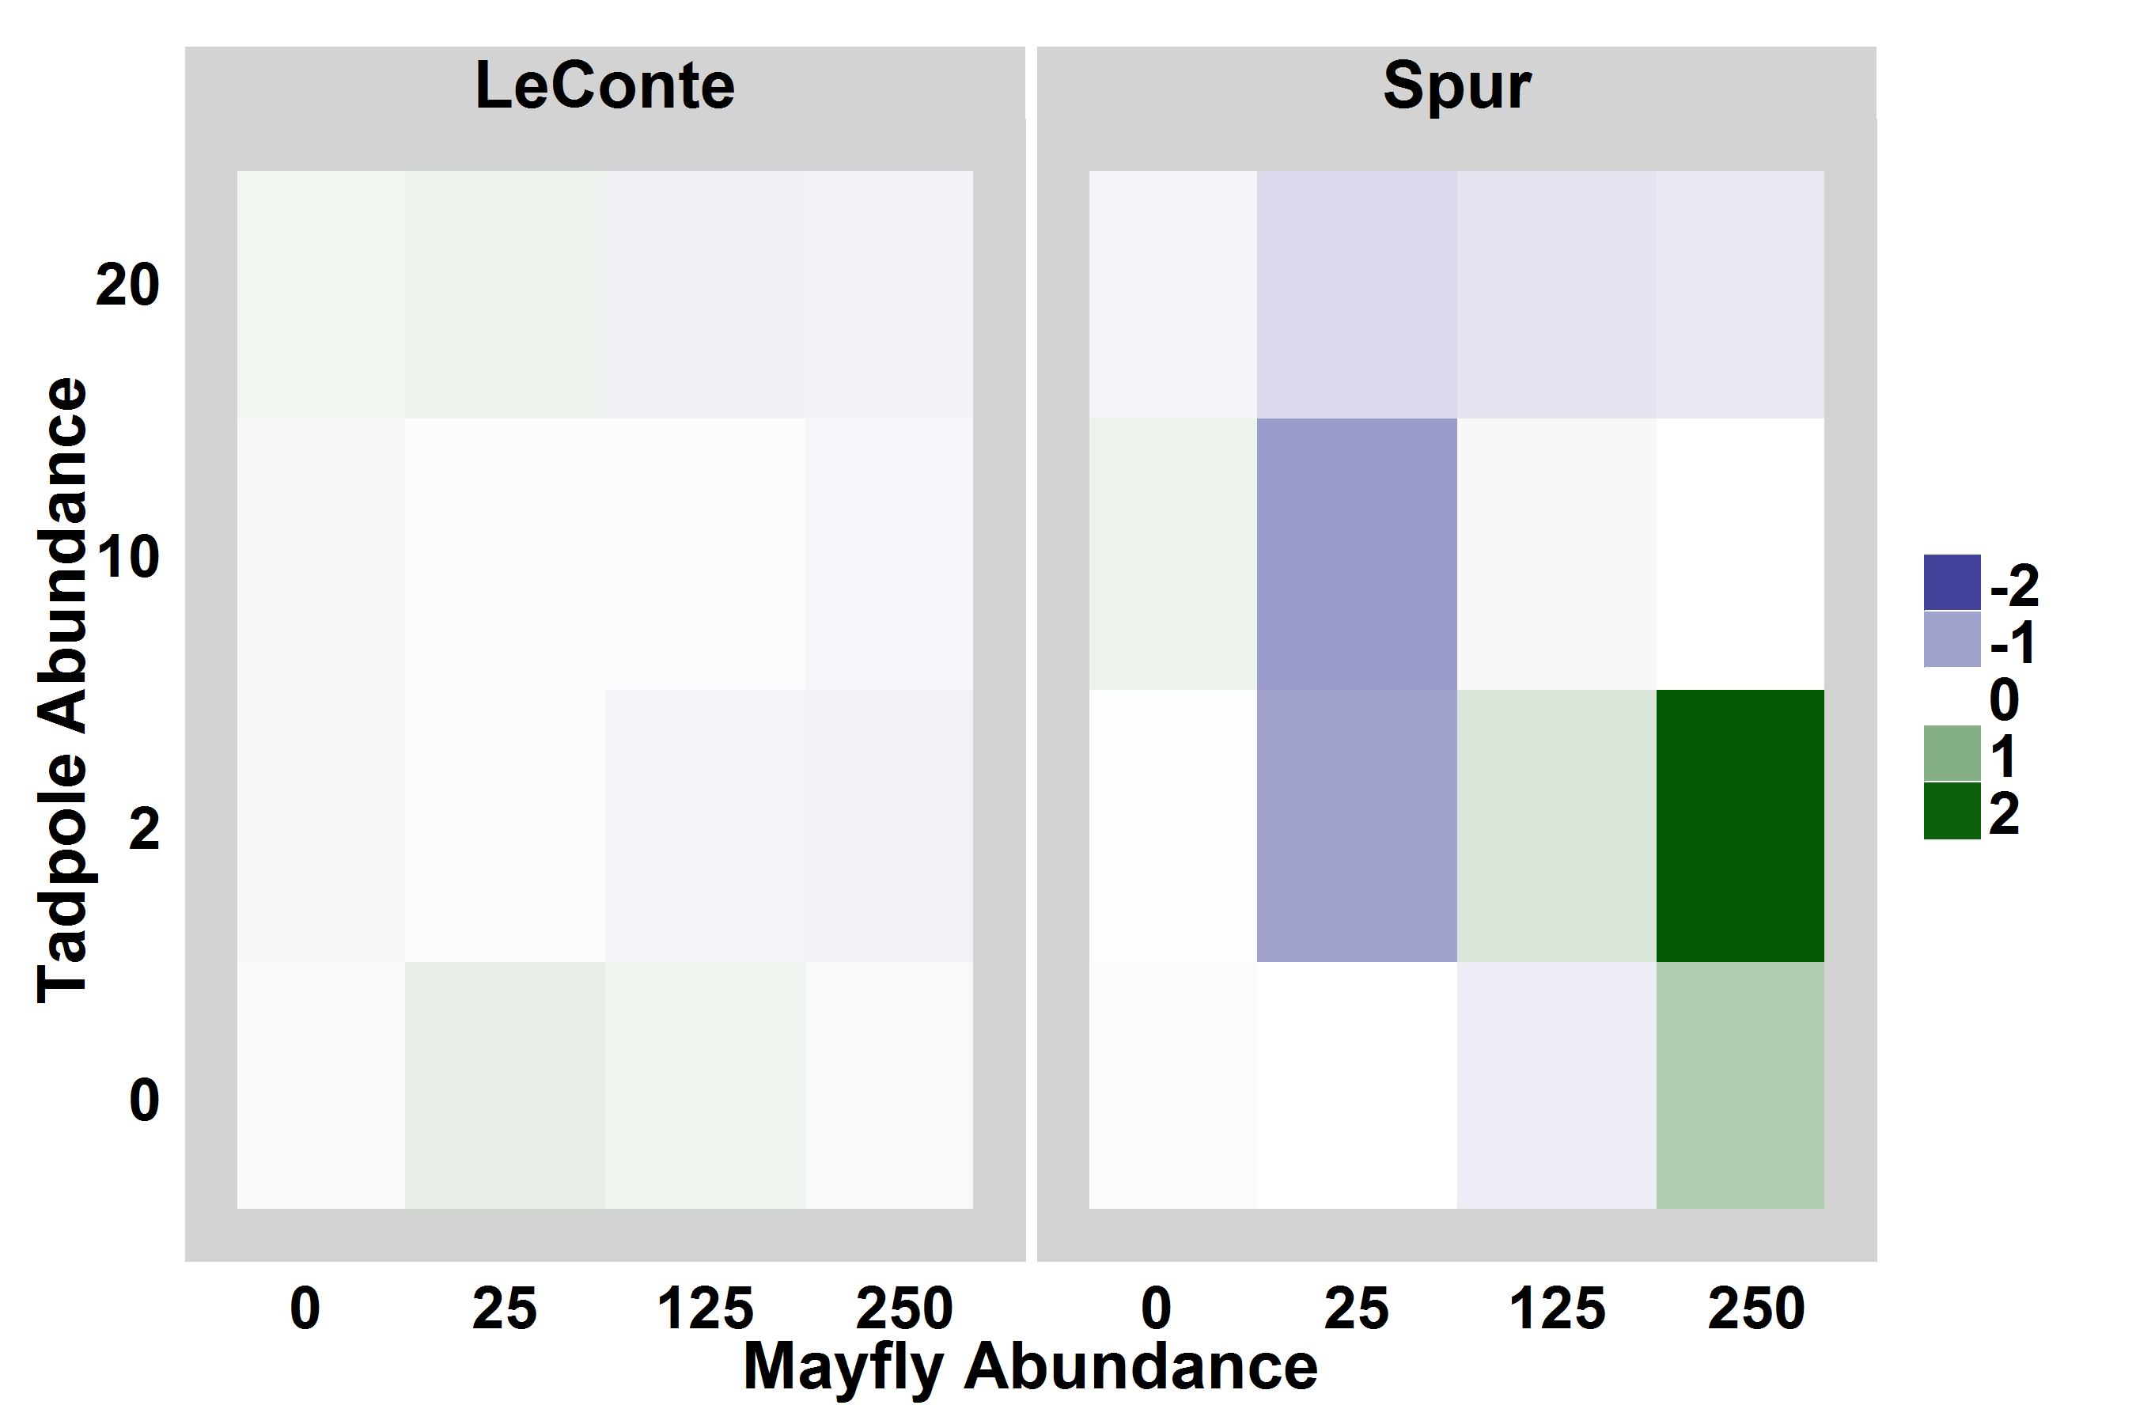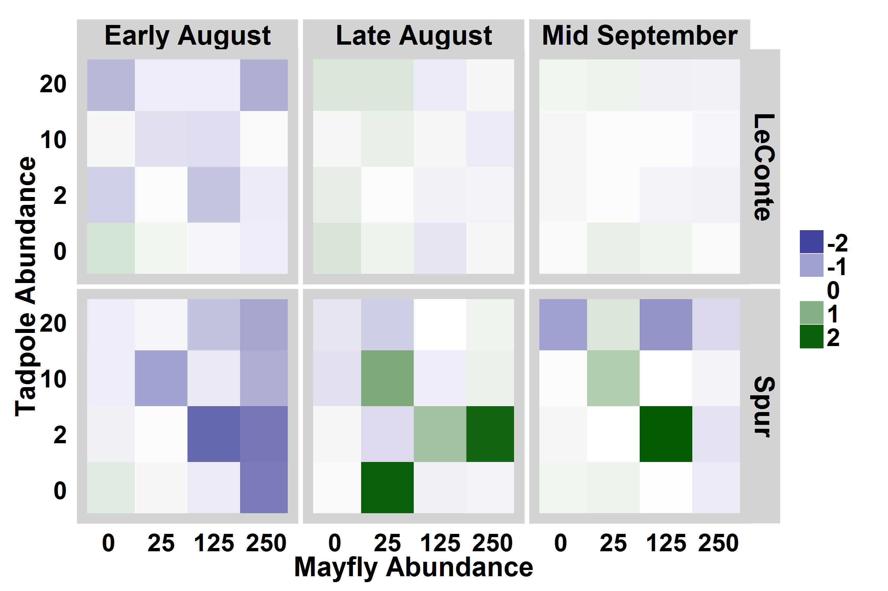

Figure 4. Heat maps showing algal abundance in each enclosure relative to location-within-lake controls. Bluer colors indicate that algal abundance was lower in the enclosure than in the control, i.e. consumers reduced algal abundance, while greener colors indicate that algal abundance was high in enclosures relative to controls. For display purposes, the relative algal abundance was log-modulus transformed.

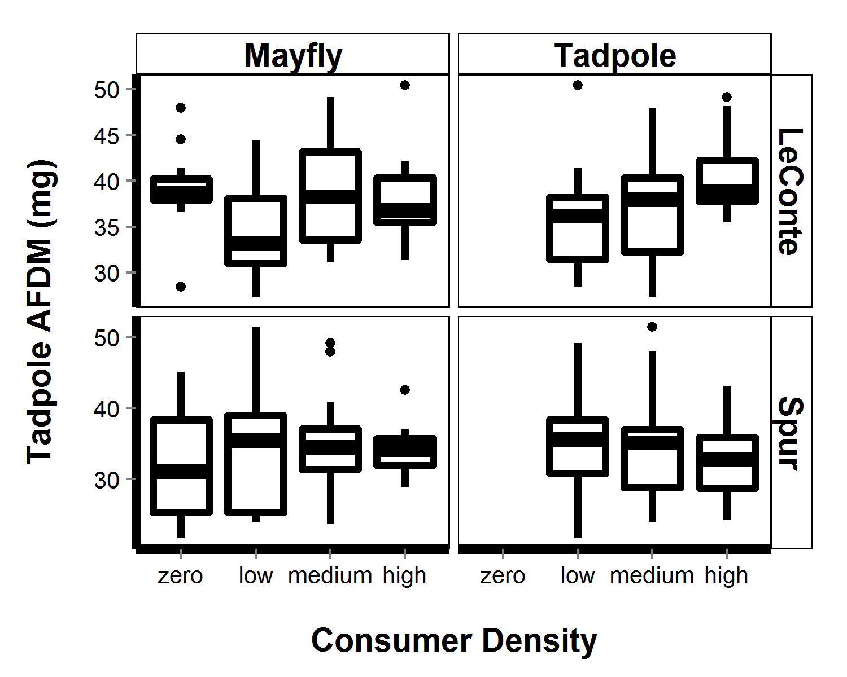

Figure 5. For field enclosures, estimated tadpole AFDM (mg, based on Gosner stage-AFDM regression) with respect to tadpole abundance (top) and mayfly abundance (bottom).

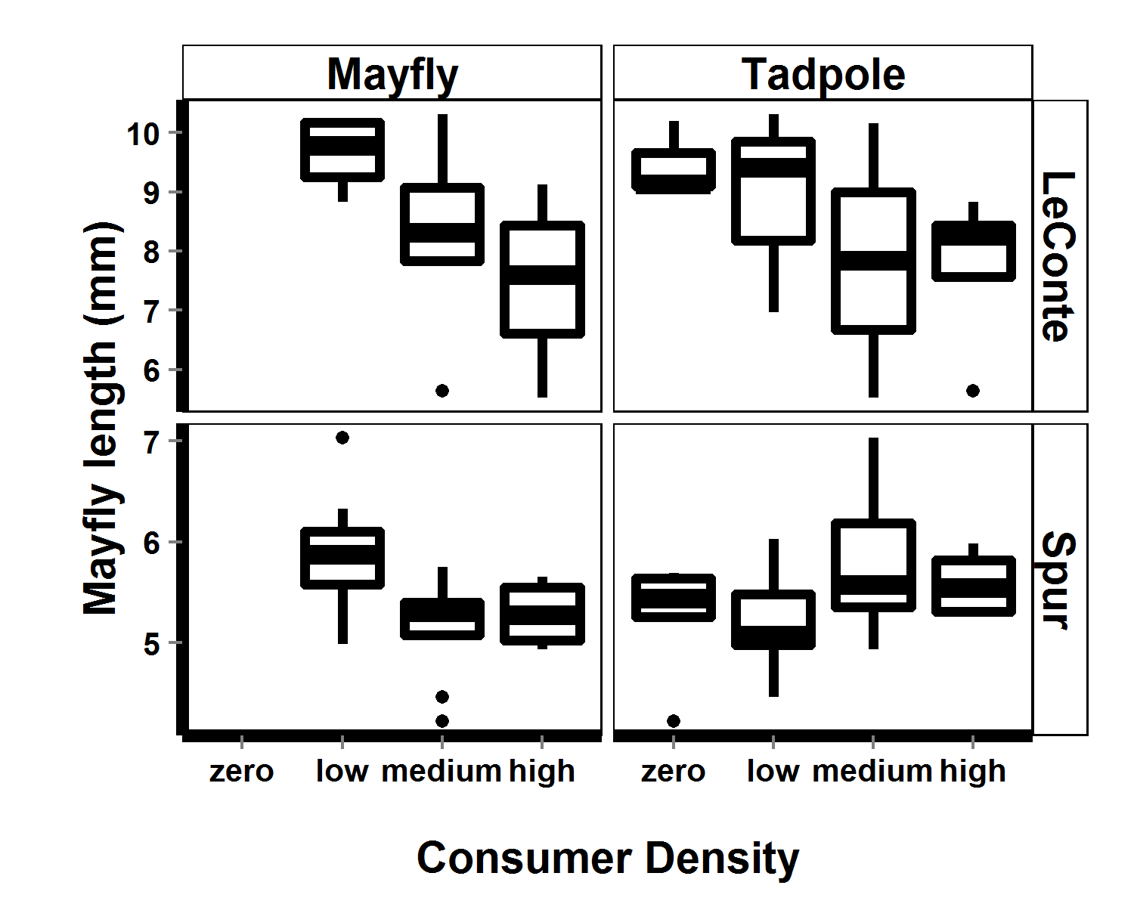

Figure 6. For 2009 field enclosures, mayfly lengths (mm) with respect to tadpole abundance and to mayfly abundance. Note difference in mayfly length scales between lakes.

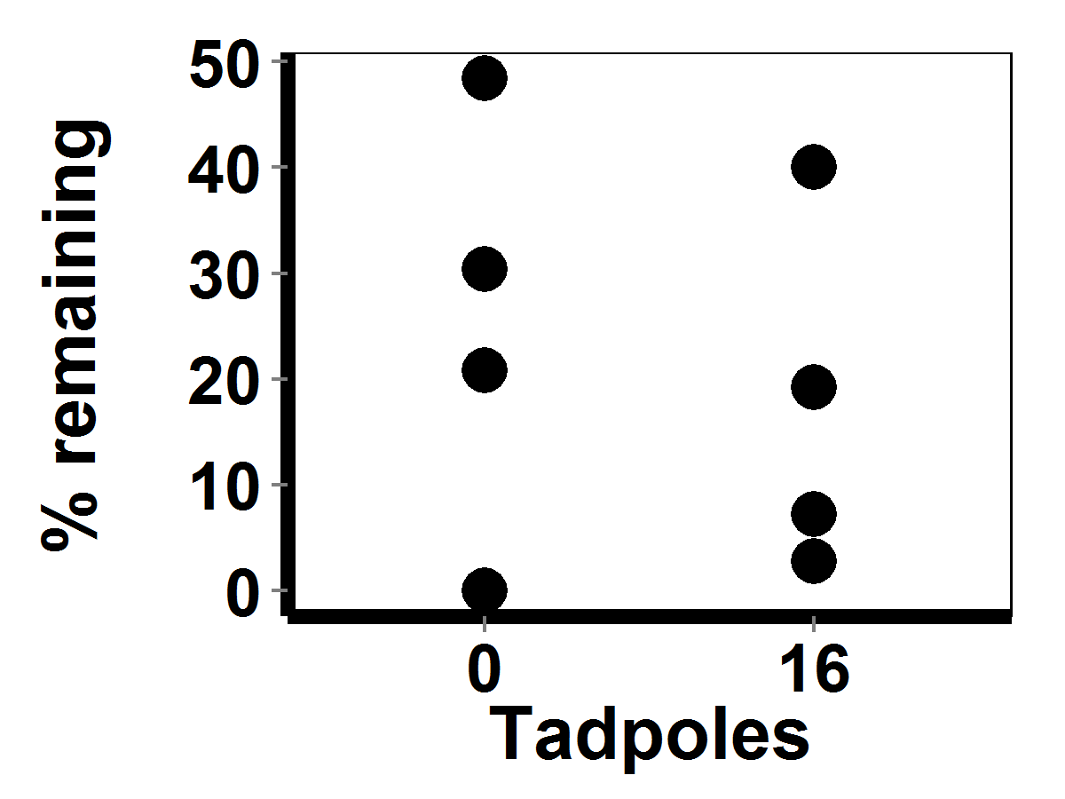

Figure New 3. Percent of original 250 mayfly nymphs remaining a mesocosm tanks at end of experiment (21 days), with respect to tadpole abundance treatments; there was no effect of tadpoles on mayfly nymph abundance (ANOVA, F2,13 = 0.4, p = 0.6). Mayfly nymph abundances at the end of the experiment were all significantly lower than the initial 250 (ANOVA, F2,13 = 153, p < 0.001).

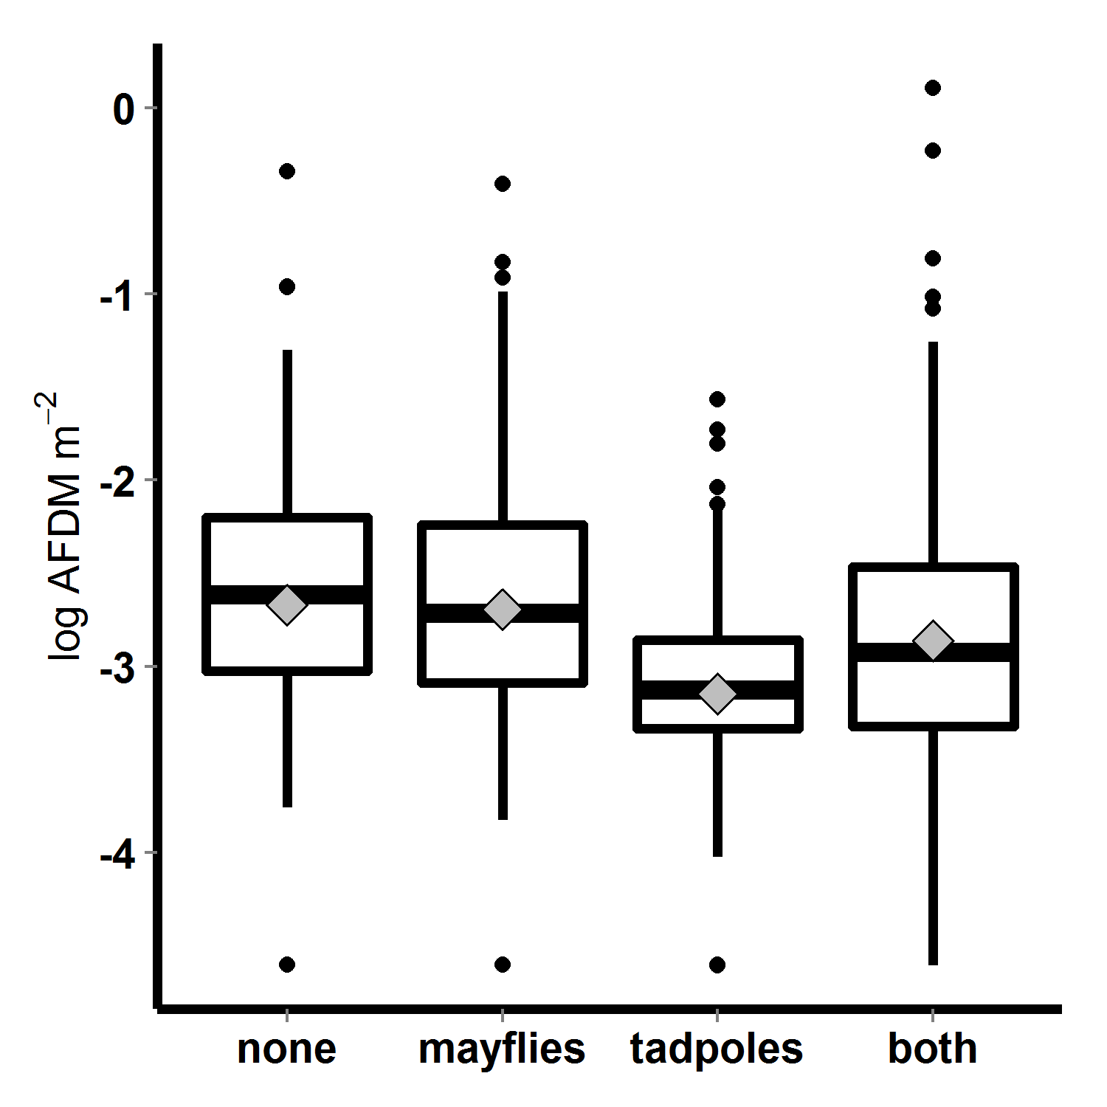

Figure 7. Algal abundance (log transformed AFDM) in 2010 mesocosms, with respect to tadpole and mayfly treatments; bars indicate medians, boxes contain 50% of data, whiskers contain 95% of the data, points are outliers, and diamonds indicate means.

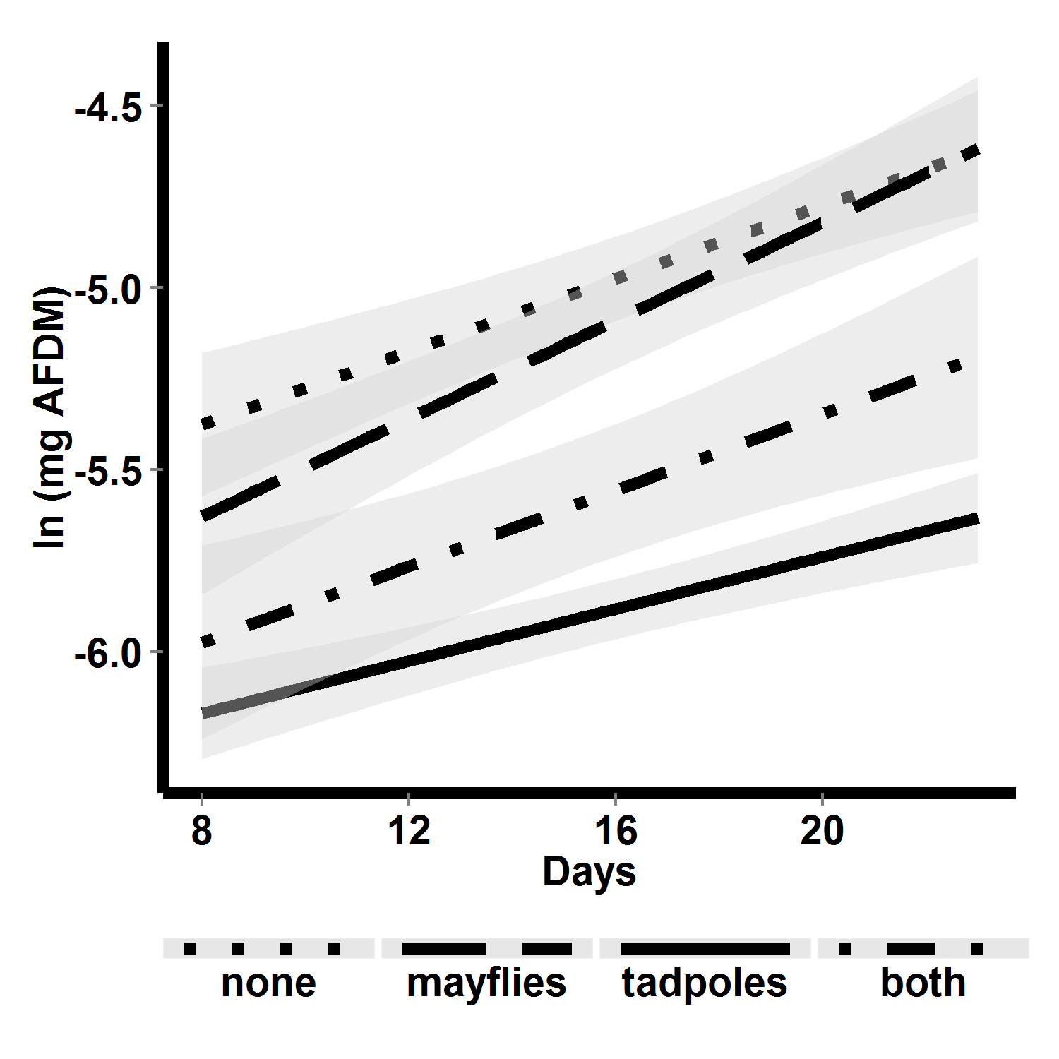

Figure 8. Algal abundance over time in 2010 mesocosms, with respect to consumer treatment. Lines are linear fits, and shaded areas are 95% confidence regions for those fits. Algal growth rates did not differ among treatments, though the abundance was lowest when just tadpoles were present and when tadpoles and mayflies were both present.

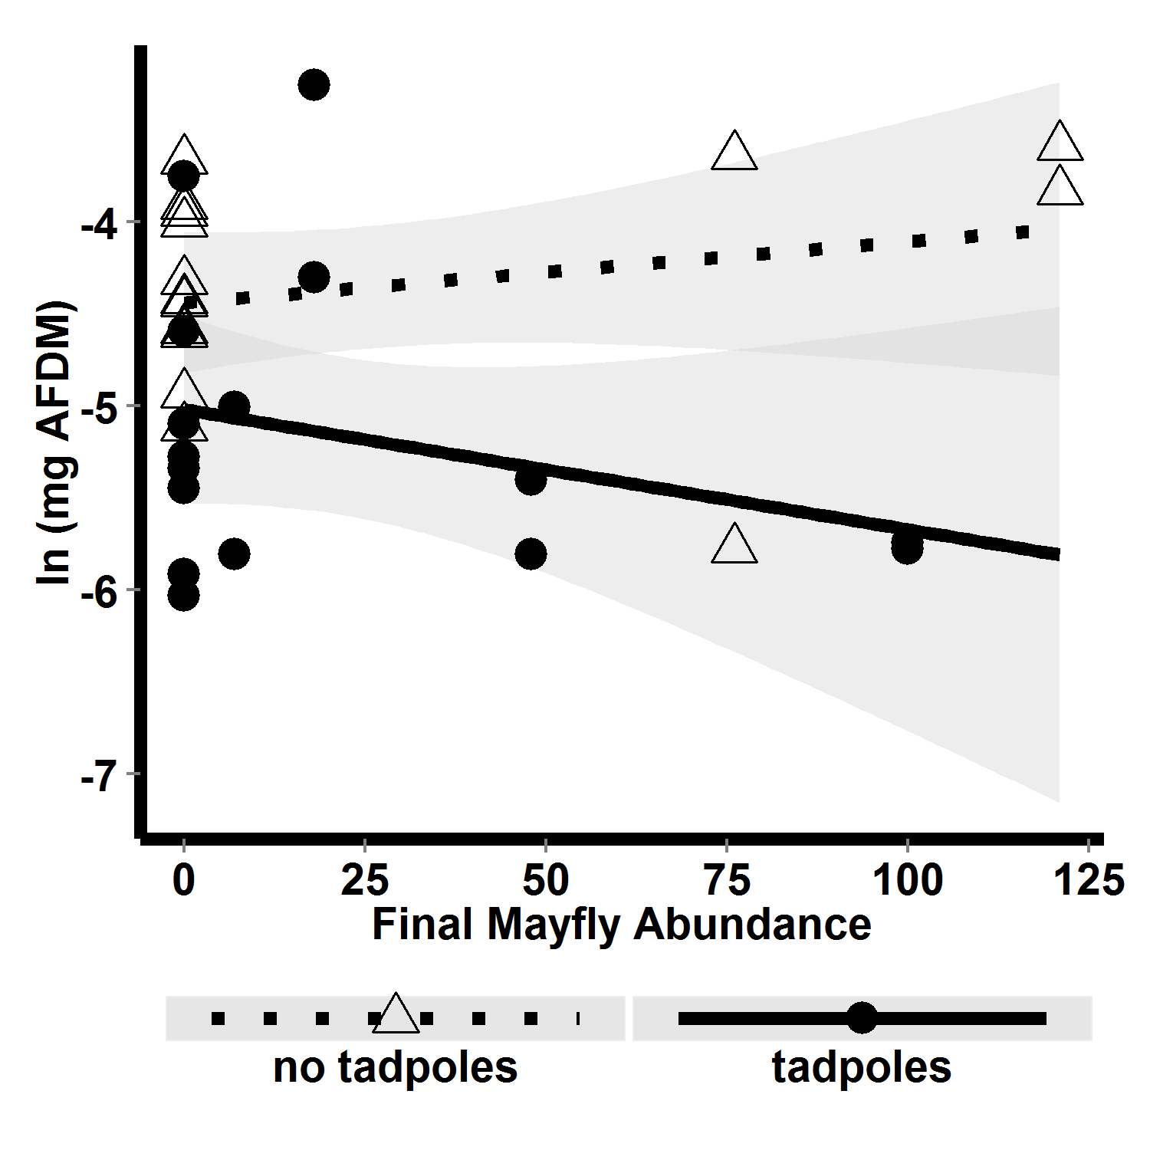

FIG. 9. Algal abundance with respect to interaction between final mayfly abundance and tadpole presence absence. Dotted line shows the relationship between algal abundance and mayfly abundance when tadpoles were absent, and solid line shows the relationship between algal abundance and mayfly abundance when tadpoles were present. Mayflies reduced algal abundance only when tadpoles were present.